Bank of England

Inflation Report

November 1996

Inflation Report

November 1996

Summary

Recent developments in inflation

1. Retail price measures

1.2 Other price indices Expenditure deflators Summary

1. Money and interest rates
   1. The demand for money

Personal sector

Industrial and commercial companies 10

Other financial institutions 10

Divisia money Narrow money

Credit demand 12

Personal sector 12

Industrial and commercial companies Other financial institutions

Supply of credit

Interest rates and the exchange rate

Short-term interest rates 14

Long-term interest rates

The exchange rate 16

2.5 Summary 18

Demand and supply 19

Domestic demand 19

Personal sector demand 20

Corporate sector demand

Stockbuilding 22

Public sector demand 23

Net external demand 23

Output 24

26

4 The labour market 27

Demand for labour 27

28

Measures of labour market tightness 29 Nominal earnings 31

Real earnings

Measurement 32

Temporary effects on wages 32

The natural rate of unemployment

4.6 Inflation expectations

Summary

36

* 1. Import prices and the exchange rate 36
  2. Raw material and commodity prices 36

Pricing by production industries 36

Unit costs in manufacturing 37

Pricing by *retailers*

5.5 Summary

Pr‹ispects for intlati‹in 39

* 1. Developments in prices, aggregate

demand and supply

* 1. The Bank’s medium-term inflation

projection

fi.3 *O* th*er* inflation projections

6.4 Conclusions

0 Bank of England 1996 I8BN 1 h57.30 1 35 8 GSM 3WV737

**Summay**

lsince, the. August *Inflation Report,* there have been three important pieces of news. First, the short-run outlook for inflation has

‹deteriorated. Second, the effective exchange rate has risen by 8%. Third, the.estimate of GDP growth in the first half of the year has been revised up, and for the third quarter is above trend.

.During the course of this year the balance of the recovery shifted frotn .net exports to growth of domestic demand, especially consumption. That trend is likely to be reinforced by the appreciation of sterling since the August /n dfion *Report.* It would be a mistake, however, to try to alter the balance of the recovery by pursuing.an easier monetary policy in order to offset the rise in the exchange. rate. That woul‹i do nothing to control the growth of domestic demand. An appropriate fiscal policy can help to restrain .the growth of either public or private consumption. But if monetary policy fails to counteract the potential inflationary consequences of growth of domestic demand then, as in the late 1980s„ tlie problem could become a weak rather than a strong exchange rate.

Even after tire recent increase in official interest rates of

!/s percentage point, it remains more likely than not that inflation

wi.11! be!above.the target at the end of the forecast horizon. And the short-run rise in i.nflation means that there is now much less chance of inflation being below .2'/zha during 1997. Achievement of the inflation target remains .elusive.

The. recent rise i!n rates. should help to reinforce credibility. But

**what.matte** most is the continuous pursuit:of a monetary policy

. which is consistent with, achieving the target in the medium term.

^To ensure this outcome, some .further rise in interest rates is likely

/to become necessary in flue course.

# Recent developments in inflation

##### i 1 Reta I r e e s r

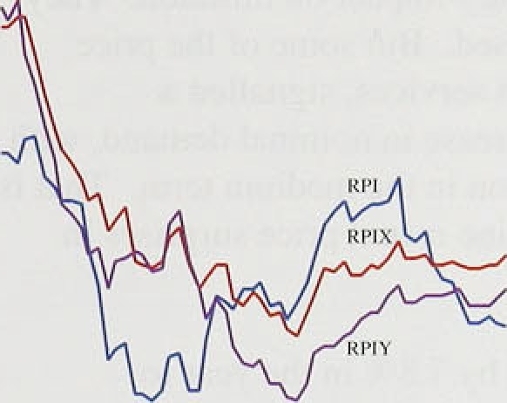

*“’ ""“* •

'

,

The twelve-month inflation i ‹ite targeted by the Governiiient; the change in RPIX—retail prices excluding mortgage intere.st payments—rose to 2.°9°J. in September, following five consecutive months around

,.2.8% (see Chart I .. I). Inflation has persisted at jusi under 37c. since October 1995.

RPIY 1.nflation, which excludes the etfecl of‘ i ndii ect tax changes as well as mortgage interest payments, rose to 2.59• in .the year.to September, ft one 2.3°% in the year to Jurie. The. twelve-iuofith headl ine (RPI) rate w'as stablc around 2.1 be between June and September’.



Infiati.on has also been low i.n most other major industrialised countries in recent years, as Talale 1.A sfiows. Indeed. .inflation in the 1990s has, on avei’age. been lower in Cound‹i, France. Germany, Japan and the United States than in the United Kingdom.



Goods and sei vices each fall into two broad categories— those which are. internationally tradable and those which

.are. not. Exchange rate movements cun uffect the pi‘ices of 1ti’adables direlctly, while domestic mai’ket condition.s arg. more. important for the p!’ices of non-tradable goods and services. The tradables coiTiponent of RPIY inflation was on a downward trend during the tirst halt of the year, .as .the effects of commodity price increases and last year’s sterling depreciation .fell out of the 'twelve-inoq!h.rate of .inflation (see Chart 1.2). Moi’e recently, tractables inflation has picked rtp as a result of thé rise in, petrol prices. .Although non-tradables

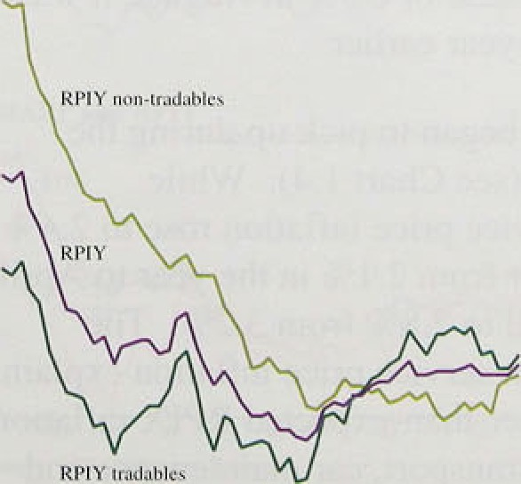

RPlYlmdeblcs

’’’ ’

inflation was::fairly subdued durin:g the first h.ilt’ of l99f›, there’was evidence of .a pick-up more recently.

Soucrs: QMSzndB•ntoCEngnnU

.Measuring. changes. in price. indices over less than twelve months .gives a .better indication of. more recent

!developments in.inflation, !although temporary pi’ice surprises make such measures voluti!le. On a seasonally adjusted, three-month.afinual.isleld basis, both RPIX rind **RPIY** ,inflation had fallen ñIIow. 2.She by June of this yeiir:. But. by September:as Table 1 .B: sfiows: the

three-month..rates:had !picked up ,again to 2.87r lfor RPIX.

**and** 3.2fio **fo?’RPIY,**

Twelve-month **RPIX** inflation outturns have been higher than expected over the three months since the August

*Re;›ru t.* That was despite downward ressure from

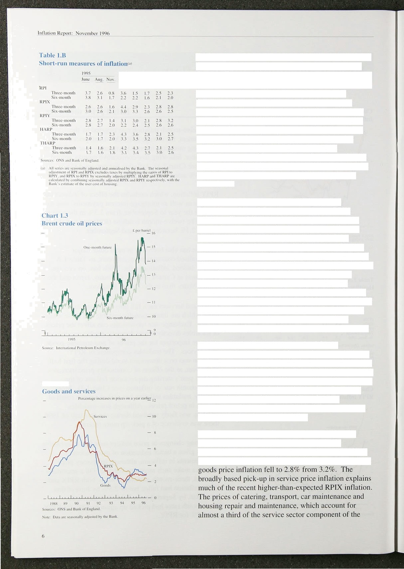

t’liai t 1.4

seasonal food prices, which fell 5.8% In September. But there were a number of unexpectedly large price increases. Some were the result of adverse supply conditions, for example in the world oil market. Such shocks have a one-off effect on the general price level and, therefore, a temporary impact on inflation. They may eventually be reversed. But some of the price surprises, for example in services, signalled a

faster-than-expected increase in nominal demand, with consequences for inflation in the medium term. That is why it is useful to examine recent price surprises in some detail.

Retail petrol prices rose by 7.8% in the year to September, adding 0.3 percentage points to **RPIX** inflation. That followed price-cutting in response to competitive pressures earlier in the year, and then an increase in oil prices in response to the indefinite suspension of Iraqi oil exports in September. But that effect is expected to be largely temporary. The price of oil for delivery in six months’ time, although it has risen. is much lower than the price for one-month future delivery, as Chart 1.3 shows. And the difference

between the two prices has increased recently, from an average of £0.38 a barrel over the 1990s to around £1.70 a barrel since the August *Report.* Once the oil market has stabilised, competitive pressures are likely to

re-emerge, partly reversing recent retail price increases.

Clothing and footwear prices rose by 5.2% in September. the largest monthly rise since records began in 1947. That increase followed low prices earlier in the year. Manufacturers may have been ‘testing the market’, seeing whether demand had increased enough to support higher prices. Although the volume of retail sales of textiles, clothing and footwear fell by 3.l% in September, after an increase of 2.5% in August, it was still 5.5% higher than a year earlier.

Service sector inflation began to pick up during the second quarter of 1996 (see Chart 1.4). While seasonally adjusted service price inflation rose to 2.4&o in the year to September from 2.1% in the year to April,

retail prices index, increased on average by 4.5 'Mr in the year to September, up from 3.8% in April. And the prieesl of .dwelling and car insurance rose by I .4% and 0 9% .respectively in July (the latest well-founded dat:i available), in contrast to last year's sharr falls. Those

.rises were1consistent with stronger demand toi’, and

.output of, services than goods over the past year’ or so,

.increasing the pressures on capacity in the service sec tor. Consumption of all services (excluding the volatile ‘other services’.component) grew by more than l.O*J.! between the tirst.and second quarters of 1995. So the recent increase in service sector price inflation is I ikel y

.to. be i.n part1 the .result of faster demand growth, wilh implications. for in.flation over the medium term. Repoi‘ts from the Bank’s Agents coi’roborate th‹it view.

The housing depreciation component of RPIX i osc b}

.I ..1. 'r in. S:eptember, fol.lowi.rig an increase of 1.2°/. in the prévious month. That reflects the recent r ick-np in house prices.

Higher-than-expected price levels will resuli in It.igl4ei twelve-month..i.mation over’ the next year. Sc›rne ot’ the surprises, such as .that tO the tail pi’ice, are !ikcly to be partly reversed. But some .‹me a sign that nominal demand .may be. increasing faster than expected, or thiit the crade-off between increases in prices and in vt›lurnes has worsened.. In either case, aggregate inflation will be higher than expected, evcn after the tine-oft’ pi’icc effects drop out .of the twelve-month rates.

##### 2 th ice d

**.Housing-adjusted** inflation

**HARP3nd:.RP:K**

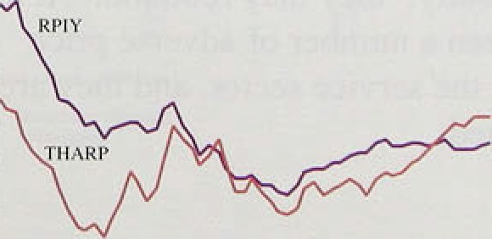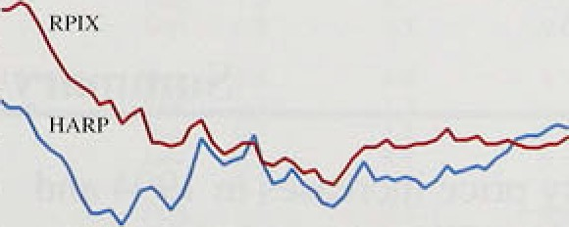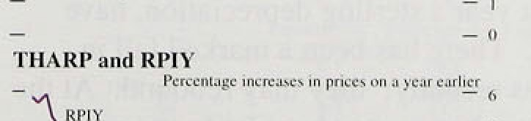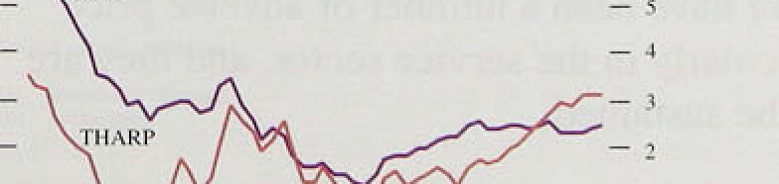

The Bank .has constructed housing-adjusted versions ot’ RPIX and RPIY which include a measure o1’

owner-occupied .housing costs in place of mOi’tgage ifiterést payments. HARP and THARP, i espectively. **HARP** arid THARP.rates have been consistently above RPIX. and:RPIY since .the spring of .l99fi because er the **re‹iovefy .i!n** .house prices which began last year (see Chart !,5)...

Several.,.prices i:hat enter the retail prices. index change relatively.infreqqently! and. by large .amounts. Such rriovements m5y. reflect cost increases that have built u: o.ver:.tim’e'. Although.'it.is.appropriate to include those

..increases..i.n.measures of the:cost of’living, they may

' ydistort rrieasures of underlyi.ng inflation. .So the Bank monitors two alternative:i.ndices,: constfucted to limit the



7





â leiisures of un‹ler12'ing inflation



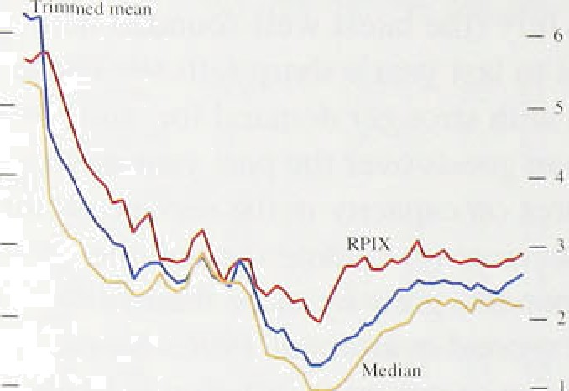

’Fiible 1.C’

C’.liu isges in ex}irnditurc dcllators ( market prices J





e.wu na11 y udjus ic‹l q u:tncrl y pcrcc nt:ige cha nges

As. Ghart 1.6 snows, tliose rrieasures of un‹ierlying

i.mation ten‹i to.be less volatile than RPIX. And they

.are often:.lower,.!becai:se!the outlying priée changes have tended.:to be .large ari‹i positive. ›The.twelve-month



around 2:2âo. So„.éñen!:afiter stripping. out the’largest price siirprises, !pos;itiyo:price shocks to a particular sector services—were irilportant in explaining’recent mO.cements in RPIX,



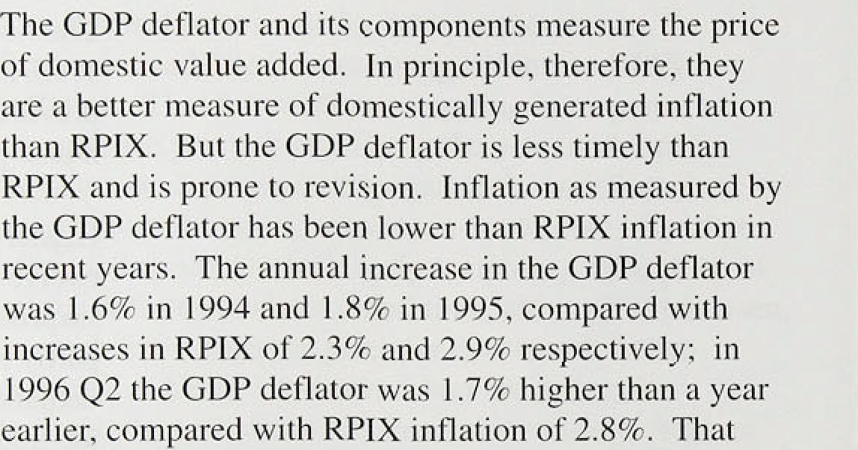

an irriportant so.urce of inflatioriary,

pressu.res, The rises in::;he impor.t and export deflators





.l:5% strgngtheni:ng of stdrliiig betweeii the first and second.quarters.: Table 1.C' shows that ;Jie i!mport ddfl /ator increased by 2.4&o.}E tiié year.to the s’econd

quarter,..havi.rig.risen 4:7&o ,}n tire. year to the first quarter; . the.Corresponding.figures for the export deilator were 2.0.fic’aqd 3.0&o respectively:



The .effects.of commodity price increases in 1994 and early lâ95, and .last year’s sterling depreciation, have Jadual!y worn.off. There has .been a marked.fall..i!n. s.easonal fond prices recently; they may:reboun‹i: At’the same time, there have been a number of adverse price‘ surprises, panicularly .in .the service sector, and they are more likely to: be sustained.

(l)”Tlie rrionihIJ:changes. in.:all Come.orients'OF.RPIX.am. weighted ac.c.ordluj resuliing dis1q.bumo ri-:.lies, -Tire..trimmed..mczn,remo.ves.lii° lBgnt nnd,



**Money and interest rates** ” 2

Broad3roney and lending growth remained high in the third quarter. As Chart 2.1 shows, bi oad money pt owth was low between 1992 and 1994, rose sharply during 1995 and remained high duri.ng 1996. Bon owing by the personal sector continued tb grow steadily in the third

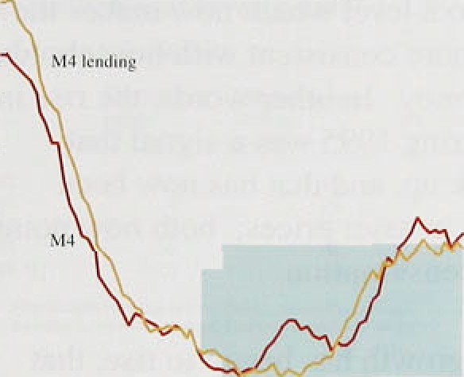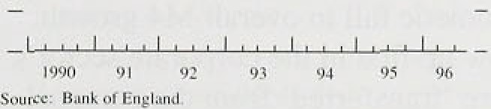

'



,quarter, in line. with the i ecovei’y i.n the housing market. M!onetary.data continue to suggest that the outlook tier consumer. spending .is robust.

Th e a d r n v

The twelve-month growth rate of broad money I M4) was fi.9% in September, above the Government’s monitoring range of 39 —99c (see Table 2.A). Chart 2.2 shows that the personal and corporate sectors accounted alrriost equally for the strength of M4 during. 1995 and 1 946.



The introduction of the gilt repo iiiarket in January led lo a .rise in the demand for. and supply Of, bi’oad mone y. which will have boosted the twelve-month growth i ate dui'irig 1996, perhaps by around one percentage point.



:I

1.

, Adjusting for that, the. twel ve-month growth i ate has been.around 89•-97c for most ot' the year. If such a growth rate is to be consistent with the inflation target. then tfie velocity of money will need to fall by 3*%—t7r a year, whereas over the past four years it tell by less than 1.% a, year. So the cunent .growth rate is most unlikely to be compatible with the inñation tai’get in the medium



7:S':

7:'.S:

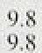





:’’ñnt’: '07:, ’’’84 30W ,’93,.



Although. there.is no :si.mple relatitinship between personal .sector deposits and consumer spending, rising depq.sits. havg in the p*st generally coincided with stfengtheniiig consumer spending. Previous £‹•y›‹›i r.5 and an article i.n the May *Qu‹irt‹i 15’. Bulletiii* ai’gued that, based on:’past-relationships between personal .sector deposits.!a:ñd their 'main. determinants. (consumption. incoine, weaJ!th and interest rates.), deposits wei‘e higher

.and.spendi.rig was lovier than usual in 1595.! Nominal



.speriding w.as'expecJed to rise during l99G, bringing deterriii!nants, consunipti.pn. That!.now seems to be



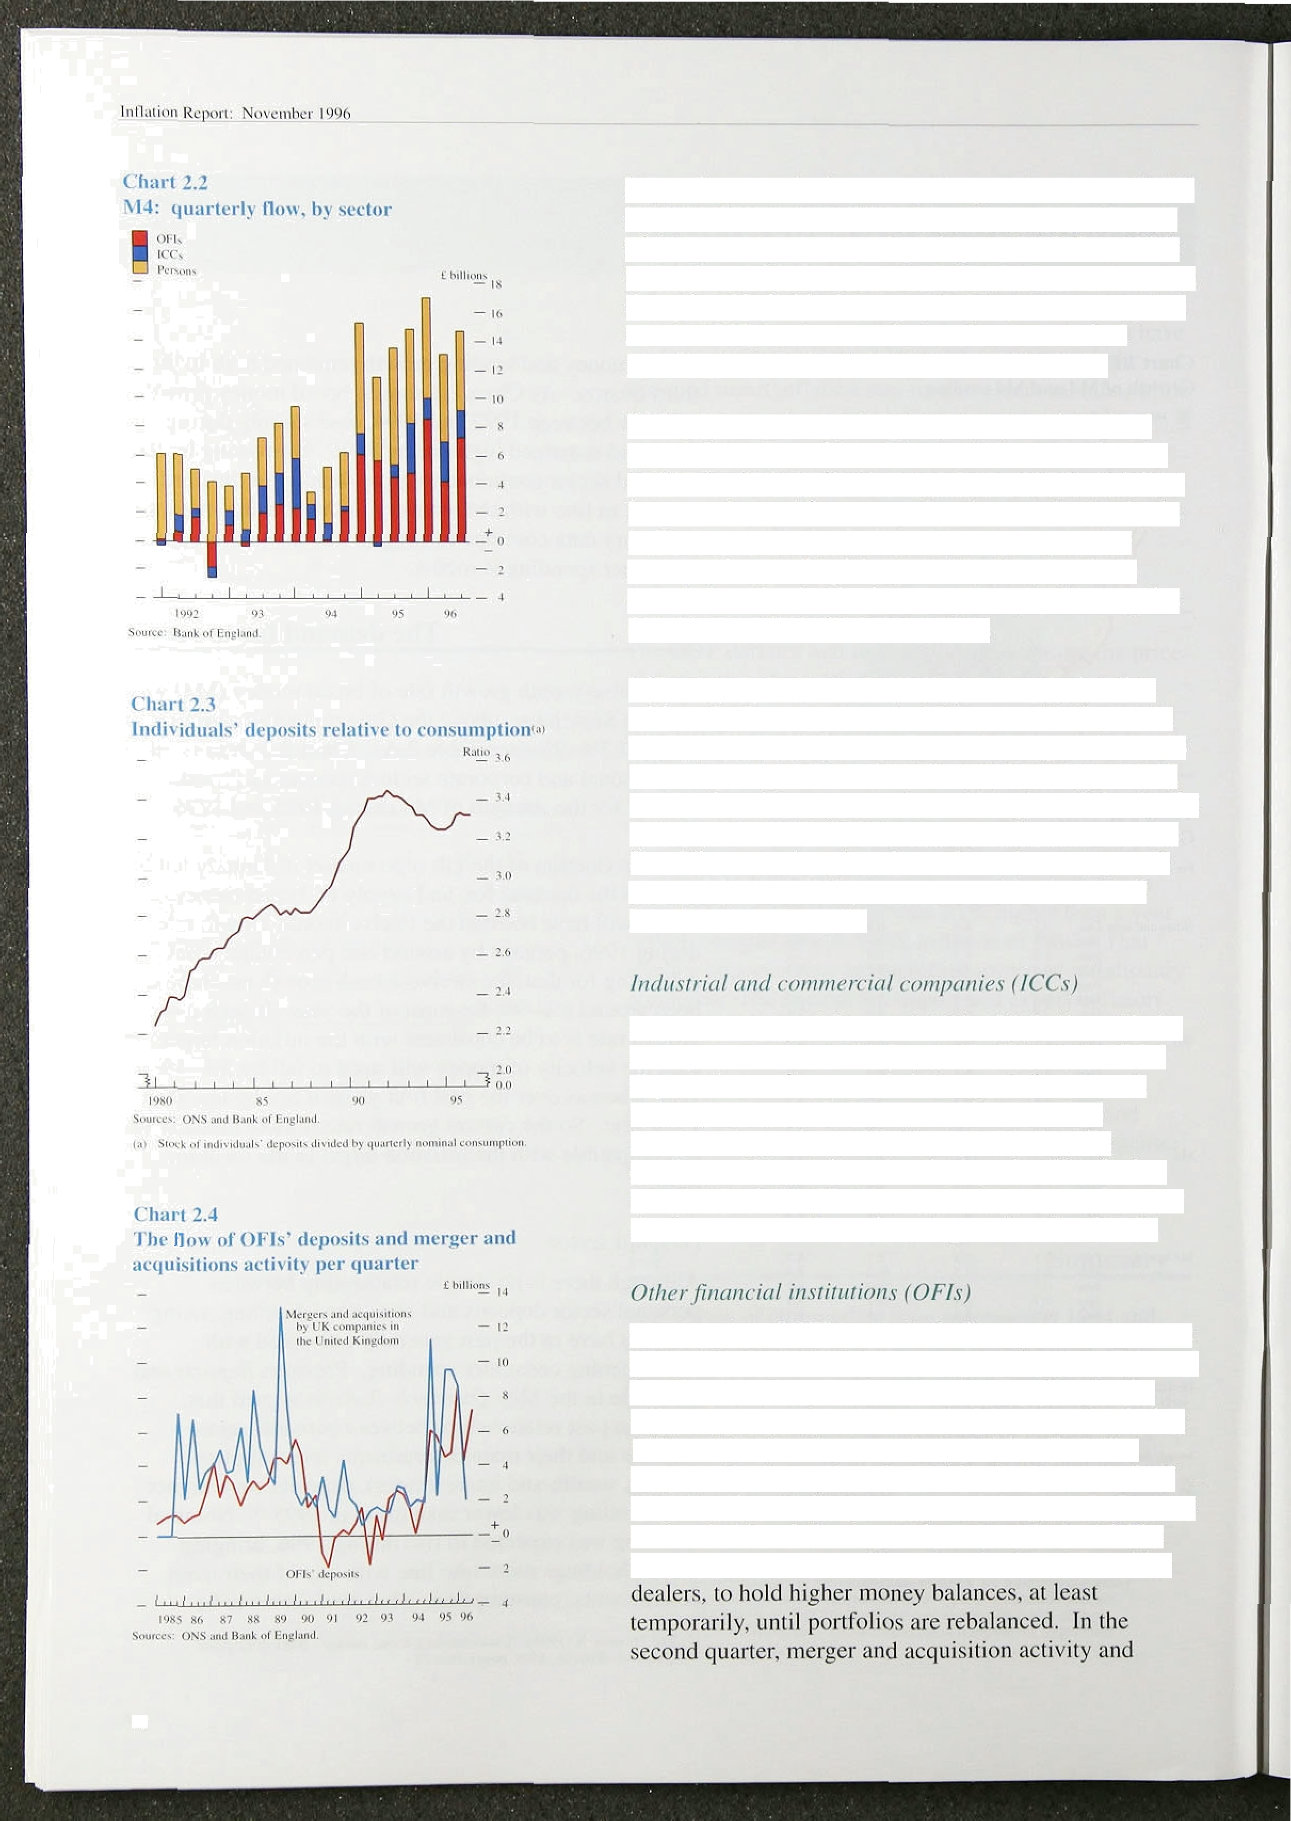happening: nominal consumption growth averaged 1.ldc a quarter last year, compared with 1.5% in the first half of this year; by contrast, deposit growth fell from 1.8% to l.69•, and fell further to 1.3% in Q3. Put another way, the ratio of individuals’ money holdings to consumption rose in l99ñ, but has now flattened out as nominal spending has accelerated, as shown in Chart 2.3.

Rising house prices and equity prices have increased personal sector wealth to a level which now makes the earlier rise in deposits more consistent with households’ long-run demand for money. In other words, the rise in individuals deposits during 1995 was a signal that consumption would pick up, and that has now been corroborated by the rise in asset prices; both now point to a robust outlook for consumption.

Although consumption growth has begun to rise. that will not lead to an automatic fall in overall M4 growth. The spending will show up first in the corporate sector’s accounts as deposits are ‘transferred’ from the personal

sector. Broad money growth would begin to fall only if a sector began to use money balances to repay bank debt. So while sectoral explanations of broad money growth are useful, it is still important to consider the pvera!l broad money aggregate.

Deposits held by ICCs rose 2.1% in Q3, in line with the average increase over the past year. Changes in ICCs’ deposits have often preceded changes in investment.

During the first half of this year, ICCs’ nominal investment grew by nearly 5&o a quarter, broadly consistent with previous rises in deposits. The further rise in deposits in Q3 is consistent with the Bank’s view that investment will continue to grow (see Section 3).

The deposits of OFIs are volatile from quarter to quarter: OFIs switch quickly between deposits and other forms of liquid assets as expected returns change. Despite the volatility, there was a clear rise in OFIs’ deposits during 1995 and the first three quarters of 1996. Chart 2.4 suggests that it may have been linked to the strength of merger and acquisition activity over that period. Payouts to shareholders following a takeover might lead OFIs, such as life assurance and pension funds and securities

10



OFIs’ deposits .gro.wth tel.I. In the third quarter, der certs rose sharply; data for third-quarter mergers and acquisitions were not available when this £‹J›r r/ was finalised, but early indications suggest a rise.' ' '

Net ins1itu'tional:in Vestment"

.42







I:n part. the rise in OFIs' deposits may have reflected a portfolio .shi.ft to shorter-term assets. In I C495. institutional investment in short-term as.sets (i ncl nding

:bank deposits) rose, as Table 2.B shows. while i.nvestment in UK coinp;iny securities fell. Th‹il gener.it pattern per listed iii the first half of 1996. Increased investment in short-term assets occur red despite the i tee in the UK eqn.ity market during 1995 and 1 99a›. and lower inter est rates on deposits in .the first half of I 99f .





The .Bank’s Divisia measure of mt›ney adds tog•ethei’ various inonetai‘y assets weighted accordin•_ to their transactions characteristics. The moi’e liquid a p.ii ticmar asset,. the more likely it is to be used foi‘ ti ansactiotis purposes. giviqg it a higher weight. As an ai’ticle in the *Qunrt‹rly* .DtI'llJ/fli argues, Divisi‹i measures ai‘e therefore li.kely to be more closely .related It› nominal spcndinp than otlier measures of money. °

In thel thi.rd quarler, Divisia money grew by 1.SFP, ils lowest growth for about ;i year. Personal sector Divisiii growth fell a little, while corporate Divisia growth rr›se. The rise in personal sector liquidity over the past yeat —

i.n the form of Divisia money bal‹inces—is l.ikeIy tt› be feedingl through to higher consumption growih.





N!arrow money growth has increased since the August

*-PEft.tt r,*f. In October, the twelve-month growth i’ate of

!no,tes .and. coin. was 7.49r, up from an averap•e of around fi% duri.rig 1 99? and the.early part of 1996. Narr‹iw monéy .growth has been above the Govei iiinent’s

_ „ .;nonitori.rrg; range of 0%—4°Zc f’or nearly four years. The

- i pick-up, in naiTow money growth dur/iiig the stirnrrier

* '* coincided with..higher retail spending growth. Chart 2.ñ shows. tire relationship between growth of notes and coin

, and retail sales: oxer the past 20 years, the correlatit›n betweerrtwelye-month growth of notes and coin .and

* • retail sales iwas around 0.9, but it fell to less than half

that in th’e! past ten years„ gartly because of’ more widespread,use.of credit.and debit. carfis.





3' I1tlI”t *.fi

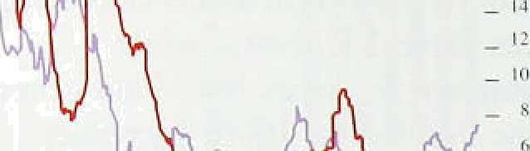

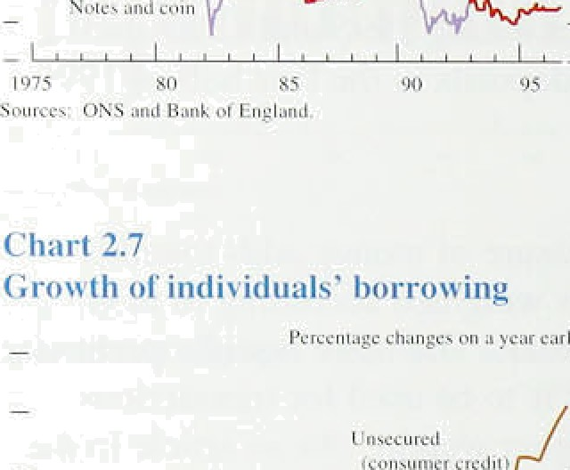





i 2

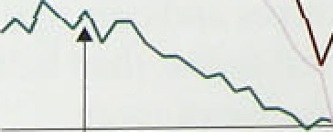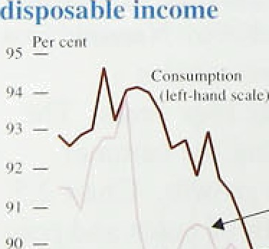

lv the past, changes in narrow money growth have often preceded changes in inflation, as Chart 2.6 shows: rising narrow money growth has, on average, been followed by rising RPIX inflation over the subsequent year. But the relationship is imprecise and has changed over time. As people have got used to low ini)ation during the 1990s, they may have become more willing to hold cash and less willing to find ways to economise on its use, for any given level of spending. If that were the case. as seems probable, then low inflation would be consistent with a higher rate of narrow money growth than before.

#### 2.2 Credit demand

Bank and building society lending to the non-bank private sector (M4 lending) continued to grow at a similar rate to that in the first half of the year. The twelve-month growth rate was 9.1% in September.

* Total lending to individuals. which includes lending by '‹ institutions other than banks and building societies, has

, g‹ithered pace. Its twelve-month growth rate rose from 5.57a to 5.99• over the year to September 1996.

Chart 2.7 shows individuals’ borrowing split between that secured on property and that which is not explicitly secured (consumer credit). Lending secured on property makes up about 85% of total lending to individuals. As the chart shows, consumer credit growth increased further over the latest three months, taking the

twelve-month growth rate to 16.2%. Lending for house purchase has also started to recover over the past six months or so, in line with rising housing turnover and prices.

How are these lending profiles related to consumer spending? Both consumer credit and lending secured on housing can be used to finance consumption. During the 1980s, mortgage lending became an important source of credit for consumption because of equity withdrawal (the gap between the personal sector’s net mortgage borrowing and housing investment). Chart 2.8 shows consumer spending, consumer credit and nn estimate of mortgage equity withdrawal as shares of personal disposable income. It shows that while consumer credit has accelerated, the cumulative withdrawal of housing equity since around 1992 has been negligible (because of the weakness of the housing market). So total consumption lending, including that secured on property, has not grown particularly quickly relative to consumer spending (as shown in Chart 2.7).











’Table 2’.t” .

**Oro*'th in.-hank..andthuilding. ‹›ciety.’ lendiitg**

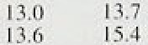



-b3!

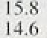

.3:7



‘ICCs continueiJ to borrow strongly, from banks and capital markets, in the latest three munths. Chart 2.9

.shoivs,that ICCS’ sterl.in.g funding (debt and equity) Seganl to risle. sharply at the beginning of I '995 after a period in wh.ich .firms repaid bank debt. In the fi rst three quarters of this year, **ICCS’** sterl ing financing wa.s rrlore than l"0% higher than in the same period last year. The strength. of.ICCs’ borrowi.ng is minked partly to hip•her

.mérger and acquisition activity, much of’ which i s

cash-financed. either through bank borrowing or di awinp down“deposits.

Borrowing by OFIs accounted for nearly a fil th of the stock of bank and but.lding society lending at lhe end of Septeniber. **OFIS’** borrowing rose duri rig 1994 and has remained high since then. Table 2.C shows that, over lhe past year, their borrow.ing contributed only a I ittle less than that of ICCs to overall M4 lending gi owtli.

The .August *Repor f* noted that Fart or’ the rise in OFI s‘ borrowing was li,n.ked to b‹›i i owitig by leasing

companies. During the fii st three quarters of this year bank lending to leasing companies was about thi’ee mimics

.h!i.gher than in the same period last year. The Fi.nance and Leasing Association rer orted that gross lending by leasing'cCoOfmM panies to finance plant ‹tnd machinery

.spendi.ng i‘ose by around 4ñ°Zr between the first hal f of’ last year and the same period this year. So par t of the borrowi:ng by OFIs is linked to higher pliinned

.irihesfinenl by ICCs.

##### .3 Su c ed t

The slupply of icredit responds to the demand for it and is also fietgrrnined by banks’ and other lenders’ wil.lingness

,to !lend. Banks" lendi.ng spi eads are one indicattir of ther.r urillingness .to lefi‹d The Bank’s Representative

!Jnterest’Rate Survey indicates that the gap between ICCs’ loan and dip.osii rates .fell over the twti years to 1.9916 Q2. .Chart 2.10.shows an alternative measure (for w.hich a longer run,o( data is available)—the spread over Libor:paid by ICCs on loan.s from international bank

.syhdicates, ! From. a. peak in 1991, spreads. had

.approximately halved by 1556; .but were! riot as low as



Sources: oNs am 8«nk of Englor›d.



(ni SpmsQs o•cr Libor weighted b loan size. Four•guaner mating









**htei lityy tlH ee-n\‹›nth interest rate**

cxpectirt **ions** br1i›re and **al’ier** the rise in

during the period. of"rapid. econdmfc growth i!n the late lS80s. Duri.rig. tire .1990s, banks .hate developed measures to improve éredit assessment, su‹ih us credit scorl.rig, which a!teinpt.to. attsch probdbilit! e s of default:

, to different loans. So, .although.’banks becaine inore willing to lend to co@oiate™custoniers fiuri!ng. tfie past'

‘' couple of years, tbey are also .ttying to d!ifferentiate.an‹i :

, to price. risks in .a more sophisliéared. way:!! :

Over the past couple of'yean,. fianks'iiave also become

, more wilhng to len‹i to, reta'il customers. Chart 2, I I shows that the .gap between cifficial interest raps .antl

* + major banks’ and buil‹iiñg societies" variable mortgagor rates has hal.ved, from over. two!percentage points: in: 1994, to just over one percentag.e pot:nt ov.er thelpast

.year. The. Representative Iiiieresf"Rat‘e Survey sho:ws! that the..gap. between retail lend!irig,and deposit rates narrowed between l993/and .1995. but rose..a.littl‹i over'

the .Past year. Because retail loan .demandihas risen steadi.ly this year, banks:and.fiui1d1ng.:societies probably



.a2n4d

I te rates

t e e ch n e ate



Official short-term interest rates in: the.IU.n.I.ted. Kingdom were 1!increased .from! 5/f‹@o..to: 6âoioni30 Cictobér, the lfirst change since the..’/‹ perceñtage .point rediuction on.

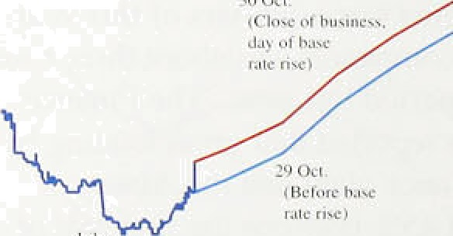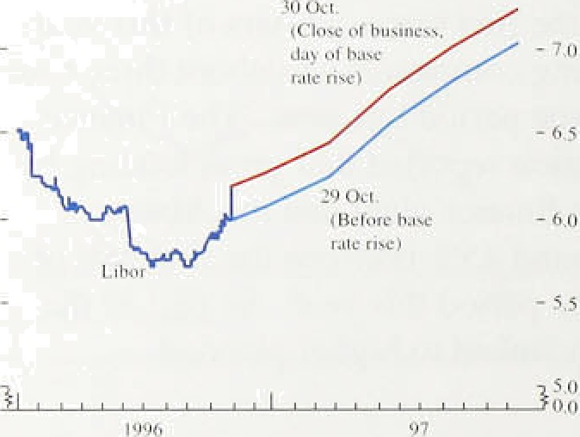

6 J,une. The three-month sterllfig Libor rate is closely related to official iriterest rates;:! éx.pectatioris of! ’’ three-month1Li‹b.or;.derived !from:futures prices,.liave increased since .the August *Repnrt.* More than half of





C’ltur t 2.13

**Sterling** three-month **interest rate** expectations‹°'

rates—=as Chart 2,12 shows,.the level of tfiree-month interest rates expectediover:tlie next. year'or so'inereased‘ by about a..quarter of a percentage polnt on..30 October:

st rLci '*ii it'n s :i :ii' IN r i:en-d ›o . . . . ’:’

On l Nove.mñer, when. this *Report* was finalised,

„ three-month Libor closed,at 6..2%..while.the sliort

:sterl!ing 'fuiu!res market imp.lied a rgte of arouh‹i 6.3& by

* , Deceisber and..6..8to by Ju!ne .of. next year. M!arket expeetations are volatile and.often shi.ft.rapidly in
  + .response to news. Chart 2.13 shows how expectations  havé .changed over tlie pit year: expected intetst rates

“ Nose between February and May, fgll between May and

rose between August and No*ember.:



ugus , a

As a:box’i:n.the previous *Report* explained; it is possible to derive the. riia:rket's view of the probability



lif*t* i/‹'i”‹iiir/ iiirer‹'vr r‹r/‹:.i’

"fable 2.D

**Brobabilit)' of‘.sterling lhrec•nionth interhank**



**raJe being Ie.ss**’



 



:As.Tel 30 Octi.



As'.ut. l- No*.







**.than** P'etes: in



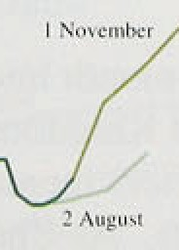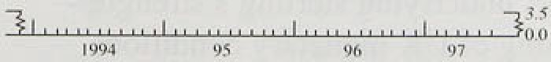

und LlFi"•h.



distribution foi tuture three-month interest rate.s implicd prices. So.. fof example, between the Augusl

:the balance of‘ probabililies âh.ifted i.fi: fa.your of higher rates. Table 2.D show.s how the perceived probabilities have changed ovcr the past three .months. Between the August and November *Rep‹›rts* tRe probability that ihree-month rates will be



.6.25%.!or less. by next Mai’ch t’e[l from around fifi “/r lo 23%. As the table .shows, the increased likelihood ref’ h i!gher. rates mainly occur red if’ter tie rise in t›ffici‹il interest rates on 30 October.

Sfiort-term i.ntere.st rates in the United Ki.ngdorn have mostly been higher than the trade-weighted average of rates in the other G7 countries since 1955. Over thc p‹ist fhrée month.s, official short-tern interest mites wei e cut

.further in Canada, France, Gei’many and Italy (see Table 2.E). That partly reflected diffcrcnt cyclical positions: over the. past two yeurs, growth in the United Kingdom has been higher than in nit›st ‹other’ indu:sfrialised countries and. ‹is Section I showed. headl.i.ne .inflation was. lower’ in Canada. Fi‘ancc.

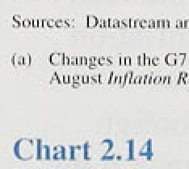

Germany .and Japan in September. Chart 2.14 shows the path of UK and overseas short-ter ir inter est rates and expectations, dei’ived from futures markets, tt› June next y:ear. The gap between UK and overseas rates is expected to widen, with UK i ates i’ising and over seas rates. broadly flat.

Long-term interest rates i.n the United Kingdom fell between August and November. Bond yields in

.Ger.many t’ell by .more. Overall, the nap between UK bond yields and those oveivseas. weighted by trade. increased. by about 13 basis points between the iwti



Long-term interest i’ates reflect the expected path ot’ short-term‘ rates and the risk pi err a associated with the uncertainty about future .inflation and real interest mites. It is possibletto work out.the implied level of short-tei’ni i!nterest tutors. at different points in the t’uture. from the



.current.rpaturi!ty 'structure of:interest mates. For example. comparing .fixg-year iriterest rates to those. at five and u half years it is possible to calcu.late a six.-ithout:li

!annualised i.nterest rate fivg years ahead. Chart 2.! ñ calculates "six-month! aiintiali3eld.intdresi 

 On l November. UK







short-term intei est rates were about three percentage points higher than German rates. In ten years’ time, the gap is expected to be about 0.5 percentage points, having t\il1en a little since the August *Report.* So the gap between UK and German ten-year bond yields, about



1.8 percentage points, mostly reflects divergent expectations of short-term interest rates over the next few years, due to different cyclical positions.



*“ „' "*

"""""”'



*“* The sterling effective exchange rate has appreciated by 87c from 84.1, at the time of the August *Reyort,* to 90.9 on l November. Chiirt 2.16 shows how the exchange

' rate has changed since the beginning of 1992.

*"’ " “ In principle the appreciation of sterling over the past

s r 11.i i i k '1 l i i 1. i i l

„ three months can be accounted for by a combination of three factors—a perceived tightening of monetary policy in the United Kingdom, a perceived easing of monetary policy in other countries, or an appreciation of the equilibrium real exchange rate.

Insofar as sterling‘s strength reflects a perceived tightening Of UK policy relative to three months ago, it could be unwound if policy were not adjusted in line with those expectations. To the extent that sterling’s appreciation reflects a loosening of overseas monetary policies, it has no implications for domestic inflation

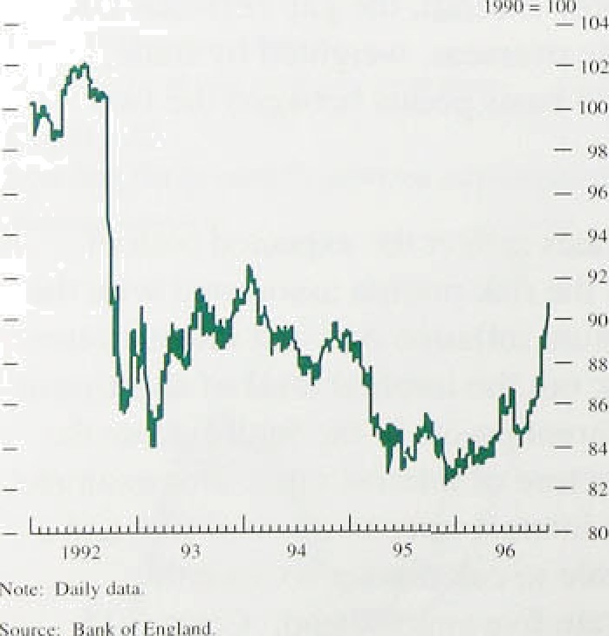in the medium term. The loosening in overseas monetary conditions would lead to a rise in foreign prices which, in the long run, would exactly match the fall in UK prices brought about by the higher exchange rate. '

The gap between three-month interest rates expected in December in the United Kingdom and those of its

trade-weighted competitors increased by 80 basis points between the two *Reprirt.i.* As Chart 2.14 shows, that

is because: (a) UK interest rates are now expected to

be higher and (b) overseas rates are expected to be lower than three months ago. The gap between implied

short-term interest rates over the longer term was little changed, however. between the two *Reports.* So the monetary factors underlying sterling’s strength— s perceived tightening of UK monetary conditions and a perceived loosening of overseas monetary conditions relative to three months ag are probably

temporary.

f I Seu Dornhusch, R ( 1976). 'Ex italians and exchange rate dynamics' pages l6—I7.

**Chart2.17**

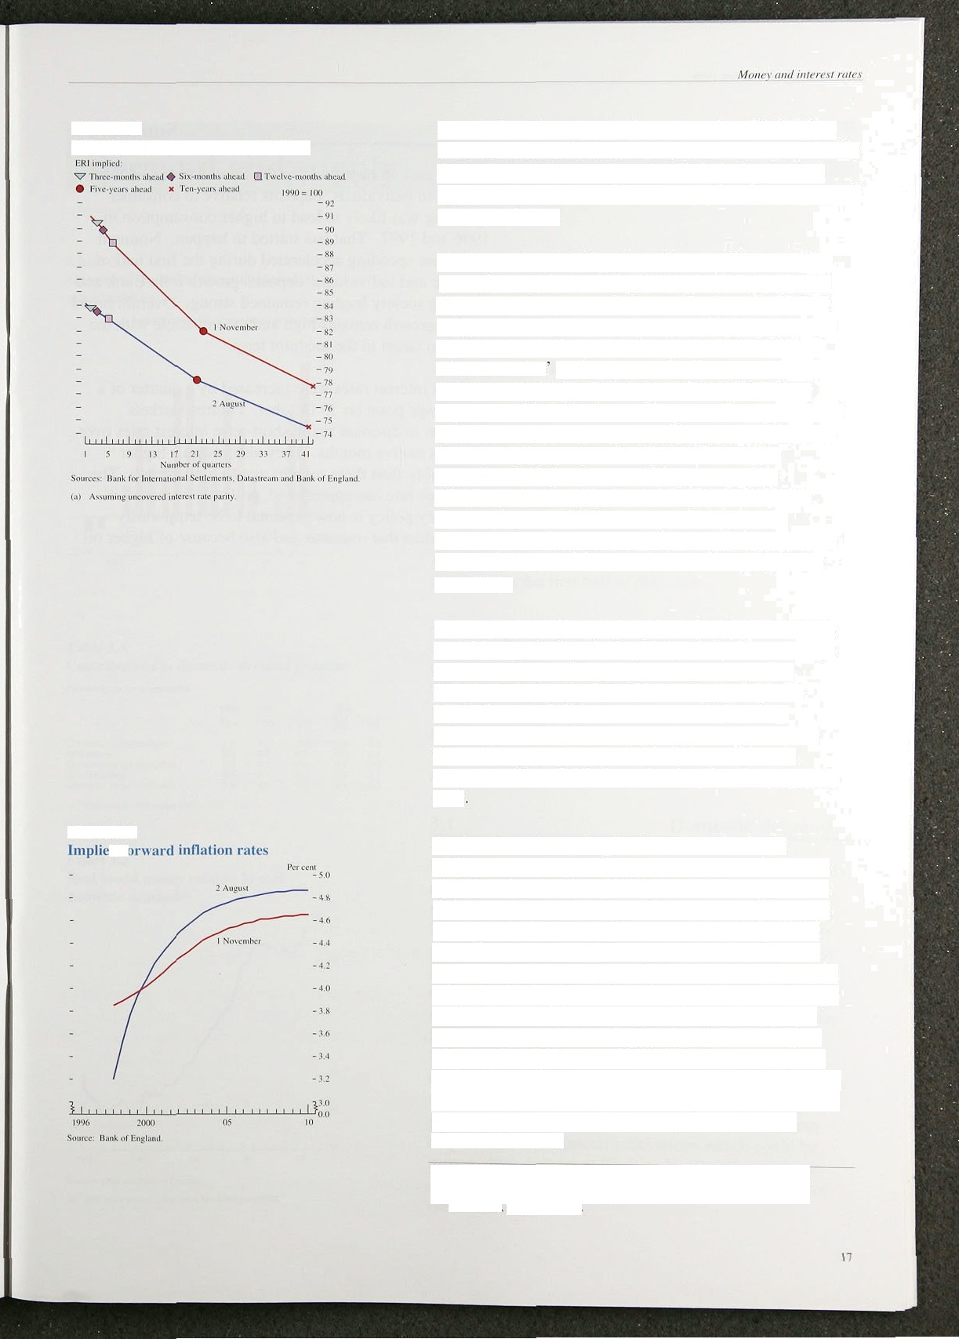

**US effective exchange rate prnft1es‹•›**

**Chart 2.18**

Some 2% of the appreciation occurred on 30 October, when the rise in interest rates was announced, and on the following two days, so it seems likely that perceived tighter UK monetary policy accounts for at least some of the appreciation.

Sterling’s rise probably also reflects real factors. The 15% or so rise in the dollar oil price since the August *Report* could be one such factor. Because the United Kingdom is a significant oil exporter. higher oil prices require a rise in the real exchange rate. ' Looking at other countries exchange rates lends some support to the oil explanation. Canada is also a significant oil exporter and its effective exchange rate has appreciated by 3% since August. even though the exchange rate of its main trading partner, the United States, also appreciated. Japan is a net oil importer and its effective exchange rate depreciated by 67 between

the two *Reports.* Oil, however, probably cannot provide a complete explanation since oil futures prices suggest that part of the recent rise in the spot price is temporary.

By comparing UK interest rates to those overseas, it is possible to caJculate the implied path for the exchange rate, assuming exchange rates change to equalise expected returns (uncovered interest rate parity, or UIP). Because UK interest rates are higher than

those overseas (weighted by trade), UIP implies that the exchange rate is expected to fall over the next

ten years. Chart 2.17 shows that implied exchange rate

path

As the chart shows, despite the recent rise in the exchange rate, the structure of long-term interest rates implies a depreciation of 15&o or’ so over ten years—a little more than at the time of the August *Repoi i.* The implied exchange rate paths are more or less parallel from five years out which suggests that there has not been much change in overall UK inflation expectations relative to those abroad in the longer term, even though the behaviour of the exchange rate suggests that UK monetary policy is perceived to have tightened in the shorter term. Estimates of UK inflation expectations. derived by analysing conventional and index-linked gilt yields, have increased since the August *Repoi-t* over the short term, but have fallen at longer maturities, as Chart 2.18 shows.

la st•rIiog’a cal exchange ratc between j973 Bftd l99Wsee Axtley. M S and Garmtt, A (1996); ‘Intcrpreting sterling exchange rate movements **November. pegs. 39d.**

In t4 iilion ReJitirt : N o\'caliber l ')')ti

### 5 S m r

For the past 18 months or so the Bank has argued that the rise in individuals’ deposits relative to consumer spending was likely to lead to higher consumption in 1996 and 1997. That has started to happen. Nominal consumer spending accelerated during the first hnlf of the year and individuals’ deposits growth fell. Bank and building society lending remained strong. Overall, brond money growth remains high and incompatible with the inflation target in the medium term.

Official interest rates were increased by a quarter of a percentage point on 30 October. Futures markets continue to discount rising short-term interest rates over the next twelve months. They also assign a higher probability than three months ago to higher rates. The exchange rate has appreciated. probably because UK monetary policy is now expected to be temporarily tighter than that overseas and also because of higher oil prices.

# Demand and supply 3

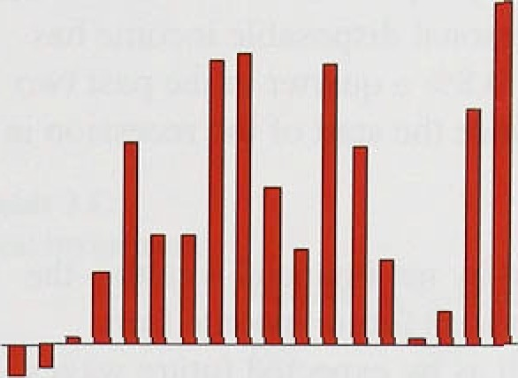



' **Real'broad rñonev relati›'t to** reul,



Onai;Stic’dem end-growth



**domestic demands** "

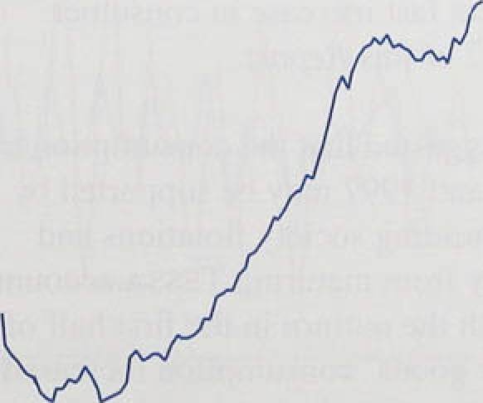

Some: OSS end Bank of fiagland.





!Real, dfirriestic demand, excluding stock building, grew at an annual.ised rate of 4°/r in the first half of this year

(see Chart 3.1), its fastest rate since the second half

* .of 1988: A fa.i.l i.n stockbuilding meant that the acceleration in demand was not accompanied by faster output growth. But that did occur in the ihii d quai ter : real GDP at faCto£ C(iSt grew by *H.b Mr. ,* its fastest rate since the end.of 1994. The estimate of GDP growth in the first half of this year has been i evised up tO around i.ts.long-run average of 2°/c—2 '/'°/c a ye.ir. There were also revisions to output in the past three year’s. The net effect of all those. revisions was to i aise the estimated

" level of output in 1996 Q2 by 8.2*?r, conipai’ed with that ñt the time of the previous *Re Perl.* Net extei‘nal deiiiand. which had boosted output growth in 1994 and 1995, did not do so in the .first half of’ this year.

Annualised growth of both nominal GDP ‹ind nominal domestic demand averaged 4'/i°/c in the fi rst two quarters of this year but is likely to have risen abo›•e 59r in the thi.rd quarter. If real output and deiiiand were growing at their 40-year avera{ie rates. rind inflation was at the Govei n inent’s target of 2'/ °/r a year or .less. that would imply nominal git›wth of arounfi 4% 59c a year.

***3.1* Doiiiestic demand**

Real'‹iorñestic demand ii4ci’eased by (),17r in the second quarter o.f this year, after rising by 0.9W in the pievious'quarter. That slowdown was accounted for by liower stocktiuilding, which reduced domestic dcrnand growth. by nearly "/‹ pe1’centage point in 1996 Q2.

as shown ’ih Table 3.A. .Real M4—broad money deflated by the increase in retai) prices excluding inortgage i:nterest payrñents—grew by nearly 7'7r in the four quarter:s to .195.ñ .Q3. Chart 3..2 shows that in the 1980s..real. M4 ro3e: relative to real demand. partly

because .fiiianciiil liberalisation inci’eased both the supply



of, and.demand..for; M4 assets: Now, real M4 is

gasy to identify finarici’al i!nnovations which ct›uld be responsible. It.is. inore likel.y to.!be.signalling a rise in real domestic demand growth over,.the next year or so **(see Sections ?-).**



*Per‘.sonal sector dem‹irld*

Real consumer spending grew by 0.89c in 1996 Q2, the third consecutive quarter in which it grew at a rate above its 40-year average. Growth of real personal disposable income—held back by the absence of the special payouts, such as the regional electricity companies’ rebate to customers, which had boosted income in the previous quarter—was only 0.1% in the second quarter. Nevertheless, consumption grew quickly. It is influenced less by quarterly changes in current disposable income than by expeetations of income over longer periods. Real personal disposable income has grown by an average of 0.8% a quarter in the past two years—its fastest rate since the start of the recession in 1990.

Consumption is affected by net financial wealth—the discounted vnlue of expected future income from financial assets—as well as by expected future wages and salaries. Net financial wealth was 18% higher in the second quarter of this year than it was a year earlier.

Gross financial liabilities rose, but gross financial assets increased more rapidly.



U.tiio nix idle • 1.2

|  |  |  |
| --- | --- | --- |
| -0 1 | 2 1 | 9 |
| 2. l | LI | n.a. |

] lepitrt rueni i i l' E-.n iron iuclii 11.7









* o.sso



House prices respond more quickly to changes in expectations than do consumer prices. So the recent increase in house prices—shown in Table 3.B—is an indication that people have probably revised up their expected future spending.

Some assets, such as homes, pension or life assurance funds, can be difficult to liquidate, but liquid assets can help households overcome short-term financial difficulties. Chart 3.3 shows that personal sector debt was very low relative to liquid assets in 1996 Q2 compared with the previous ten years: consumers are likely to be more willing to borrow now. That is consistent with the recent fast increase in consumer credit noted in Section 2 of this *Reporf.*

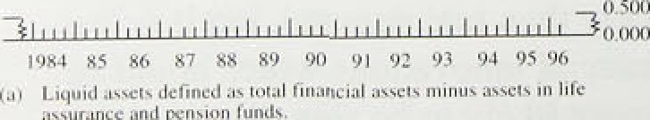The previous *Report* suggested that the consumption of *durable* goods in 1996 and 1997 may be supported by ‘windfall gains’ from building society flotations arid takeovers and by money from maturing TcssA accounts. That was consistent with the outtum in the first half of this year, when *durable* goods’ consumption increased by 4'/i9‹, three times faster than the increase in other consumption,

Retail sales volumes grew by 0.8&o in 1996 Q3, after rising by 1.4&a in 1996 Q2. But that slowdown may not

f9.r«n‹i ir/ *rural* .iiiJJ/J/r

i!ndicate .slower consumption growth, for two reasons.

.’First, .retai!l sales .represent only about 407a of

.consumption. .And second, sales in the second quarter were boosted by tourists’ spending during Euro 96. reducing retail sales growth in 1996 Q3. Tourists’ spending, because it is a.ssigned to. exports, would not havetaffected .consumption in the national accounts data. The .introduction of the National Lottery at the end of 1994 reduced retail,sales growth i elative to consumption groivth last year. That distortion has now 1arp•ely

‹disappeared.



**Table,3.C**

Real investment.’



Real .private investment grew by nearly 3°ñ in the secr›nd quarter of this year, ,after even stronger growth in the previous quarter. Growth in Q2 was cntircly due to the purchase of aircraft. Table 3.C show.s invesliTlent grow th

i.n di.ffei ent sectors of the economy. Investment in the ONS”’ ‘other industries’ —mainly lñe ser›4co



uickly in the tirst halt ot’ this year. Fastei



investment growth in the service sector than manufact:uring was consistent with stronger growth i.n the demand for, and output of, set vices than goods over’ the past year or so. The British Chainbeivs ot’ Commerce Su:rvey suggested that investment intentions in the service!sector wei e h.igher in the third quarter than their a;verage.since the. survey began in 1989.

.In the. first half ot’ this year, manufacturing investment fel.l..shaipl.y, after a large rise in the second halt of last

.year. Over the past 40 years, change.s. in the output of’ iñanufactiirers have o.fien preceded changes in their investrriént experiditure, as Chart 3.4 shows. That could be becaqse firms are not very good at anticipating tuture

:chan:ges in ‹remand. The fall in investment in the first ” half.-of.tti.is year was consistent with the .Blowdown in

_ „ ’’ output growth last year. .And the expected increase in

.man.u!facturing. output in the.second half of this yeitl’ lT1cl'V take .some. time. to stimulate more investment. Despite



„ that, i.nñestment intentions were .abtive their lon•q-run

— .averager in the .th.irfi quarter, according to the CBI industrial Trends lsurvey.



: As well us. su:key.. evidence. there are other.indicatom that tofa'l pr{.date.investment .is likely to quickly. The .market:.va!luation of capital exceeds its replacement cos’t. Ttiat means it should be profitable for firms to:tissue new eq:iity:to.fi.nance the purchase of



: capital goods. The price .ofiiew in estntefit goods,

relative to other goods,’was very low .in 1556 Q2

lnllatiou Report: Nuveiiif›er l99fi.



,4 iuiuaf gt ‹its **th of’ h‹iusing turnu*er and**

prim atr *ector d» elling investment





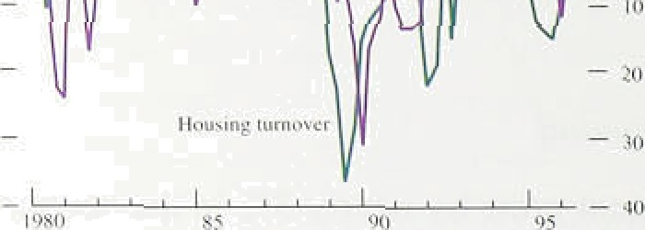

’ l’ahle 3.D

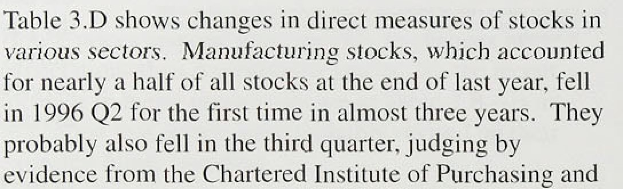

I.’hiiisges **in stocks** '

ti bill inns. I 9"Jfl yriccs







Private housing starts h.ave risen considér'ably since

the start of the,year. And turi1pver.in tire housing market has risen over the.past twelxe. months: pin.the three‘ months to Septeinber;.it' was. 12%:h.fgher than a year' earlier. Chatt 3.5 s;hows',tliat; :ofier the past'J 5.years.: changes in turnover. have ten‹ied:to.coincide with changes in investment in'..private dwellings: .Sp Fécent. falls in that category of investment are.likely t'o be reversed soon if the .recovery in:.the housi!fig market conti.nues.

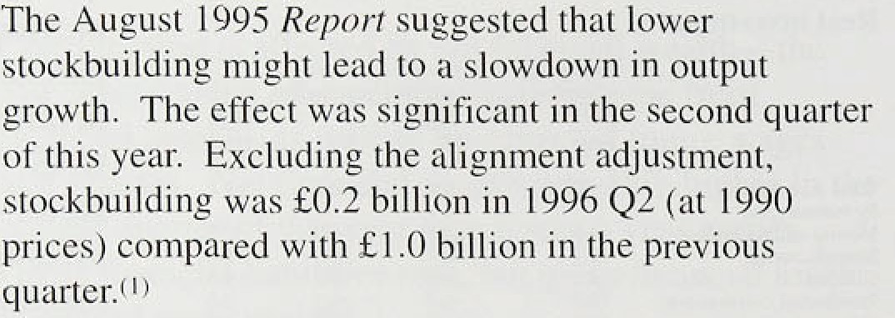

i:ndustries—th’e.second'largest holders of stocks— i:ner.eased at ,arou.nd the:r long-yun .average lai;t.year, but ‘in the: first:halt.of this year ro'se.twice as quickly:

###### ’Tire. difference in stock building across sectors in thy secoird quarter. was" consistent with survqy evidenc

.noted.in the.previous ffeporf—that in the first half of this

.year :rrianufacturers’ held .too many stocks, and who1‘esa1ers too:blew. More.recent surveys. indicate that’

.rnanqfacturers' excess.stocks have fallen since then, but ’’t1iat':wholesalers may have built up stocks too rapidly: tire balance of.wholesalers.reporting tliat stocks relative to.expected sales were!more!than adequate was above its. ten-year average i!n tire past,three months' GBI Distributive Trades Surveys. Retailers’ stoéks have.1 fallen accor‹iing to.tñe same surveys, perhaps reflecting strong growtit in retail sales over the summer..



to the.Exp.enditvre,lneagpre.of.GD.P. ao-as tn. mBEe:it talfy Wilft tfie ‹iutput'





*i ‹ ‹ «i •›‹i* «v»

**Chart J.6**





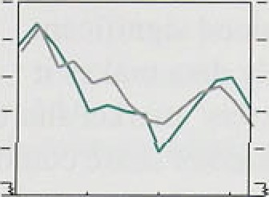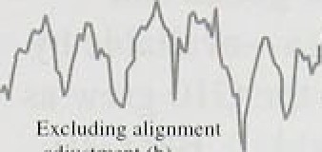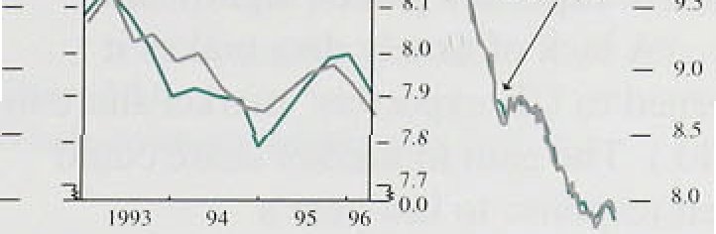



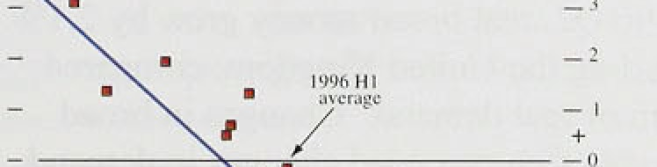





**Chari!3:8.** ’

**Current.acc.ount..deficit’azid:RPIX int1ation/**





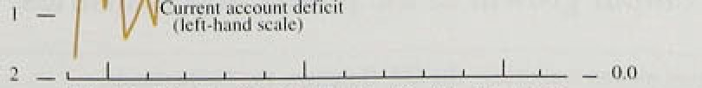

1934 â5 % Z3 88 #9.9 Q1 .§," ’93 04,’ .96

Chai1•3.fi shows thatethe ratio of stocks to sales has,fal.len si!nce 1980, reflecting improved

stock-management.techniques. Stocks .rose relative to salts. in the first half of last year, then stabilised. and fell in:.the first half of 1996. Last year’’s i i se was not unusual. over the past 40 years, there were ten

!occasions when the stock-to-sales ratio rose iiioi‘c quickly. It seems unlikely that improvements in stock-management techniques have come to a sudden

end. The stock-to-.sales i’atio should.contin ue to fall: in the .short run, as.firths i educe their stock overhang: and in!.the! long run, as further i r' ovements in stock management reduce the desired i’atio..



fn constant prices, overall public sector’ demand rose by

.0.5% in 1996 Q2: public investirient increased by 3Ur. while general government consumption rose by ().2°%. Gérieral govern.ment expenditure will fall i elative to **GDP** over the next two tinancial year’s, according to

HM Treasury’s Summer Economic Forecast (SEF). The projected large falls in government investment are planned .to be partl.y offset by private investrrlcni under the.Private Finance Initiative. So far this financial year‘, cumulative central government receipts .ind outlays have beeri broadl.y in. l.ine with .the pi’ojections for the whole

,year set out in the REF.

**3.2 Net external demand**

The externa!1 current account was £0.5 bill ion in surplus in the.second ,quarter of I.996—only the second quarterl y surplus.1since 1587—compared with deticits of around fi1 billion tin the previous four quai’ters. That irriproverrient was largely due to increased surpluses on trade in services partly related to, Euro 96—and on

!in,vestment inco!me. .In the first .half of the year, export ’volurñ.es grow. a .little less quickly th‹in import volumes.

.Dornestié .deinand .in..the Uni.ted :K.irigdoni. relative to

.demand ifi its major. trading. partners, rose. The cuiTcnt account was;slight1y stronger th‹in expected gfven relatiive. demand,1as shown in Chan. 3.7.

Yihen .‹domestic diiinand grows! mord .quickly ,than the potential.supply, of an ,economy, excess deiiiand can be met .iriittally›by oxérseñs supply but ultimately must be

dampened through price i.ncreases. An early signal of

.excess .demancl! buildiiig.cup ih the second half of the 1980s:. teas .the large increase ! n the cu!rrent ‹account



 

broadly flat over the past!two years„ .suggestihg.JJiat there has!not yet been. a 'buil‹i-ilp of.excess’ deriiand.

In the tirst half of this year: exports. of.goods:and services grew. by 3’/ %, The‘itra‹ie:‹rata—available! by country—suggest tiiat UK.exports to ihe G10 grew as.: quickly .as .those to the rest!!of the world.('. .But G10

!otal i!mports:grew .by only ',/‹% in.Erie .first .half of the year, implying that UK ex.porters. ga.ined si.gnificñiit market share there. (A lack‘of tiii;ely data m*ke’s it u!nclear w.hat happened to .U.K exporters* market'share!in the rest of the world.1) The!gain: i.ni:rriarket share could have. been o.delayed response .to last year’s

l c e l

e fecteve eenhs ganate h e n h he adh sted for

" ' ' changes. in relative pro‹iu.cer prices was low last.year.

_ , , But it rose in the first‘h5l.f of:this year; an‹i willi:1iave risen..further since. then .because!of:tlie large iiomiri l

— *’ exchange rate appreciation: That suggests a risk to ’UK.

, exports: .the recent gains. in in rket share iriay not be

, sustained.

-»

In the year to 1996 Q2, .real broad’, mofiey gJew1:by 2: l %:. in the Gl0,.excludi.ng the United Kingdom,. compared with l.29• gr'owth 1of real ddniiin‹d. /Changes!1 I:n .broad money growth have .often!prece.‹red.changes i.n!‹remand :

' growth over the. past !l5 years,.so :the"grofith of!.real

br:

ll

h of eal 'de ande

e sehs Howeven he Sheet ofi’

expansionary monetfiy: policy, iiii ” t be some hat ofifset.



.by fiscal poliéy: most..Europeqn go.veiiirrie nts hate anrrouficed restrictiVe budgets’for t.heir I.orthcoming

.fi.nancial years.

€’li•irt 5. I t1

Quurtrrly gi ‹in th ul’ reiil I•DP

UK iiiiport voluines/grew quickly th the first.hal.f of.this. year by around 2,'//a@o in each quarter ompared wi!ih growth::in...total.final expénditure of about’ 1&: a quarte(.. Iii"the.past‘’ten years, iinports have tended to .grow about.



Kin:gdom, so:im port.growth this year..has not.been





Whdle-economy output, valued at 1990 prices, is

'“’ .estimated to.have groyfi by 0.8&o in 1996 Q3, faster than

i.n the previous six quarters (sge. Chart.3.10). Service s.ector output increased by 0.9& in the.third:qiiattn;



thee-G7i.:B.elgiuin,-.thoo.:Nitherlatids,





Manufacturing firms’ output fell between the third q!uarter of last year and 1.996 Q2 as manufacturers

,sought to.reduce their stocks. B.ut.manufacturers increased their output in 1996 Q3, and in October,

!manufaeturing new orders increased at their

fastest .rate si.nce September 1994..according to the CIPS survey.

**,Chart 5:11,**

Wñole economy labour **productivity**



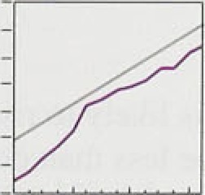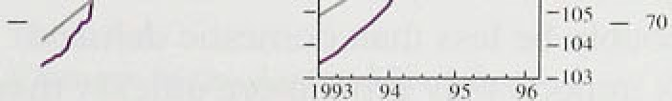

-. I'I0



Following the measures taken to control the spread of BSEi such as the culling of cattle, agricultural output fell sharply in I99fi Q2: it reduced GDP growth by about

0. l percentage points. According to the ONS,

.agricultural output rose markedly in the third quarter.

Output depends on the amount of labour employed and how much each worker produces. Section 4 of this *Report* looks at the demand for, and supply of, labour. Because productivity tends to increase over time due to technological advances, it is useful to look at the level of productivity relative to its long-run trend. Chart 3.1 l shows that productivity was slightly below trend in

1996 Q2. That suggests output could grow more quickly over’the next few quarters without increasing the deman‹i for labour.

Sectors:of the economy grow at different rates as the relative demand for various goods and services changes.



Table 3.E shows that the output of the service

sector, for example, has grown more quickly than most others iii this .recovery, and contracted by less in the recession. The transport, storage.and communications iiidustry has grown particularly quickly in this recovery,.boosted by the development of mobile telephoñes and satellite communications. If resources

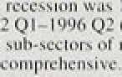

ii•*

.-*.*.,

i-*.

•.i

1•l



.cannot be shifted into an industry quickly enough to match growing demand, price pressures may occur even

.if there is spare capacity in another part of the economy. That would only affect aggregate price infl8tion if spare capacity exerted less downward pressuf:e thin the upward pressure exerted by e,quivalent capacity constraints. Measures of the

**fii'spersion** in'growth rates **can** be calculated to assess the

**.,dégree of sectoral** change. They .suggest that the

**:reallocatinn of** resources needed last year was not Unu8iially high.i



- * I I





1. Su

Domestic demand, excluding stockbui!ding, grew at its fastest rate for seven. years ih1.the first hal!f of i.996.

Consumption growth should.remain .h.igh... Consumers have probably revised up their expected futiire:income, and their debt burdens have fallefi ftirtlier.. Survey evidence suggests investment will grow strongly, consisten.t with incentives froiñ ielative’!pnces. Ahd the housing market recovery should boost. construction-related investment:

**GDP** grew at above its long-run trend rate in .1996 .Q3. Reduced stockbuilfiing held back output .growth in tlie first half of this year. Although stocks may continue to fall relative to sales over the next couple of years, the effect on output growth is likely to be small. Output is. likely to continue growing above fts long-run average over the next few quarters.

Overseas demand growth is likely tto rise over the next year, but it will probably be less thâir‹iomestic deiñand growth. As a result imports may grow more quickly than exports in the United Kingdom. The recent exchange rate appreciation will probably reduce net exports too, at least in the short rufi.

26 ,

The labour market











Houn viitkcd:per:.week.tsL 

LFS !‹ ai:measure I). I•' .' LLH





**Job.surveys'**

" 4

The labour market tightened in recent months: clai mam unemployiiient fell faster in the third quarter and there was a significant fall in unemplt›yinent on the international standardised definition during the summer. An estimate of the gap between total hours woi’ked in the economy and those people ‹tie prepared to offer narrowed.

Nomi.nal .earnings growth is increasing. Undei’l y ing notil.i.na:l earnings growth it›se from ‹i low oi 3'/.°J. in December to 49c i.n JuIy and August.

##### .4.1 Demand for lnlioui

Employment rose by 3ñ.,000 in the second t uai ter, *aI ter*

fallifi% by 41,000 in the first, according tti the Workfoi’ce

.in .Employment (WIE) d;it‹i (see Table 4.A). The Labour F-orce Survey (LFS) showed a 70.000 i’isc in employment iti the .su.miner, i eveivsirtg a 34,000 tall in thc spring.

Most job surveys suggest that employment continued to grow ion the second half of lhe year—particular ly i n the servicé sector (see Table 4.B). The September’ Manpower Survey of employiiient prt›spects showed a balance of + l77c intending It› take on staft’ over the following quarter, compared with +1 2' c a year ear lier. The. latest British Chainbeivs of Commerce (BCC) Quarterly Survey reported that the demand for’ laborer had i:ncreased rapidly i.n the third quarter in both the servi'ce sector afid. in manufacturing. The. Bank’s A*ents also, imported increasing .demand for 1;ibour in the ihii d quarter. The .latest Confederation of British Industry (CB'I.) Industrial Trends Survey was more pessimistic about inanufacturing. report:ing that manufactui’ei’s have



;:, Al.l.,the, rief’new j.obs created durihg the recovery wei’c



CBI.ltd 'Manufnciunñg.- I:â -4 ..-Hi -17 -10 - i.i ! - i3 part-timé. accordi:rig ,to the LFS: full-time employment



‹•, ! g;j;§¿• {,';t which .has, fluctuated arouiid a more or .less conmant level oyer:the past 25 years is a. more comprehensive. measure. of labour..use. Totfil hours ivofked have risen by 3.9%.since the recov.ery started. in:.1992. .aCCording to the





C“liangeS in total hnurs u orked



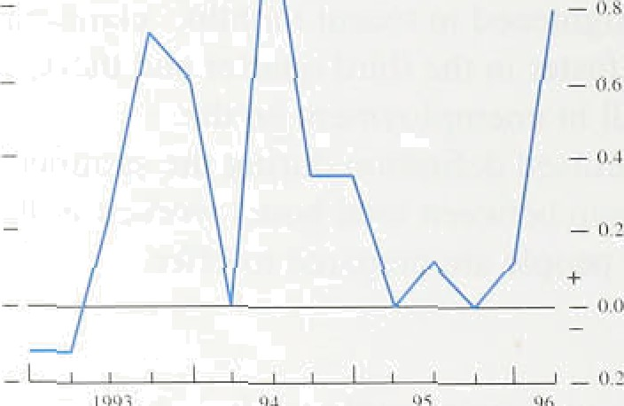



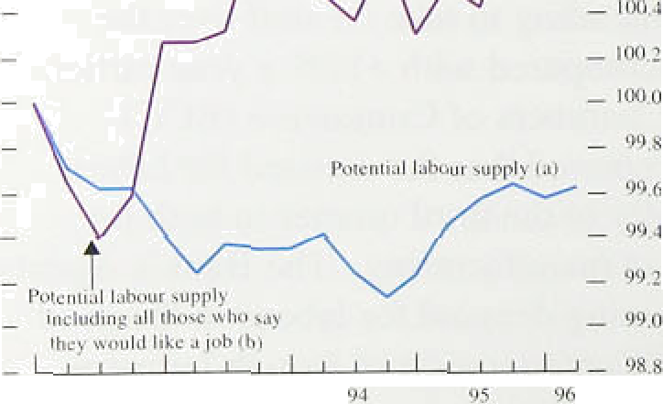





LFS. There was a slowdown last year: hours worked were virtually flat between spring 1995 and spring 1996, before rising sharply over the summer (see Chart 4.1).

## 2 S l of l bo

The number of people willing to work exceeds the number currently employed, as It includes those who are registered as unemployed and others who are not officially counted as unemployed but who say they would take a job if they were offered one. ' As when measuring labour demand, the total potential supply of *hours* is more relevant than the number of workers available, and some people with jobs are willing to work longer hours. For example. the LFS shows that, in 1995, 259a pf men and I 0&• of women who worked part-time would have preferred full-time work. In Chart 4.2, actual hours supplied are added to estimates of the additional hours part-timers would like to work and the hours which those who are actively seeking work would be willing to work (assuming their preferences as to hours are similar to those of the currently employed).( 2 The chart shows that the number of hours on oNer increased during most of 1995, before flattening off over the past few quarters.

A broader definition of potential hours people would be prep;qred to offer includes those who are not actively seeking work but who would like a job—such as some of those in full-time education, those discouraged by the state of the labour market, and others who would like to work but are not available to start immediately. The LFS provides estimates of the number of people who fall into that category. Chart 4.2 includes that broader estimate of the potential supply of labour; it rose during 1995 and in the first half of 1996.

Demographic trends also influence labour supply. The population of working age is estimated by the Government Actuary’s Department to have risen by I.l% in the first four years of the recovery, compared with an increase of 2.7% in the first four years of the

previous recovery; it is projected to increase by a further

0.9 over 1996 and 1997. compared with a rise of 1.1% at the same stage in the previous cycle.

1. Ii is reasonable to assume that pnrt-timers who soy they wani io work longer hours are willing to work at prevailing puy rates. That is less clear for the unemployed. ponicula*ly those ri•t actively seeking work.

 *In* f99S, *accordi*n *g io* LFS data, 92' of en\plojred rrten. and 55% o/ employed women, wor1ed full-time witk the re8t port-time. Same 7S% of male pan-timgrs and 10a of women pañ-timer» said they would prefer to work full-lime. The rough estimate of the potential supply of hours attributes the average length of a full working week (39 hoors) to these, and I § hours a week to the remaining part-timer; orher people willing to accept a job are. counted as willing ‹o supply hours in similar proportions.



##### 4. 3 M s res of lab m k t h

In the short run, the interaction between the demand fr›r, and supp.l.y of,..labour determines labour market ti.ghtness. The most .common measure of’ labour market tightne.ss is the number of unemployed claimants.

Claimant unemployment fell by an average of 25.7t)t) a month in the three months to September. In the thi ee months to June, unemployment declined by an avei‘apc of 12, l ()0 a month. In October, the clairnonl unemployment figures will start to be reduced by the Jobseeker’s Allowance. ' That will cut thc perioct of non-means-tested benefits for the unemployed *tram* twel.ve to six inonths. The immediate effect will be to

.remove only 35,000 people from thc claimant count over the next six month.s, accoi’ding to the ONS, because those unemployed for more than six ni‹itiths wi JI i’emain ion. the claimant count unless they choose not to sign on..in order to continue their National Insurance contribution record. Over ti me more people may he removed..from the c‹›unt, if it improves their incentive to l.ook for work.

'30 -



yrñent 'râte,s:



The!international standardised definition of unemployment, measured by the LFS, is unaft’ected  administrative changes: the LFS asks individuals directly whether they have been looking t’ot a job in tt4e past .four weeks. The total fell by 50.0(IO in

summer l99ñ.

Another measure of labour market tightness is the

rion-employment rate. °' Indeed. non-employiTlent may be nioré appropriate than claim‹int unemployment as an find:icator of labour market tightness across cycles, because”unâiriployment was reduced .in the early l9°)0s by people withdi ‹iwing from the labour force—some of whoin may be discouraged workers. ' The UK



non-erñployrñent rate fell from a peak of 28.8Ur in

’.l 993:.Q2 toi 28:.l 76 i.n 1995 Q4; it rose slightly in the tii’st

:half of 1996 .to 28.39c. That overall decline w‹is smaller



19801Q2 a:,simiIar.stage of the previous cycle in non-employrfie rit (see Chart 4.3).



:couui. . T-he

1vi1 I:dms .ol’f hoc

’ in.the



In principle. the most comprehensive measure of the state of the labour market is the estimated balance between the potential number of hours people ate

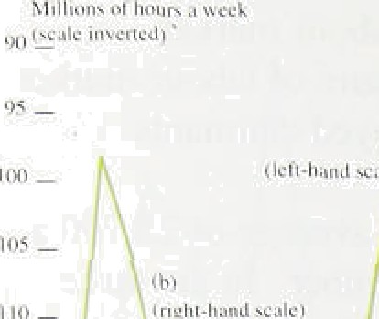

, , pt epared to work and those hours actually worked (see Chart 4.4). If the potential supply of hours is defined as

›• those offered by people currently actively seeking work and part-timers who say they would like to work

* + full-time, the labour market tightened between the winter Of 1992 and spring I9S5 and then stabilised, betore

” tightening further in the summer of 1996. If all those who say they would like a job are included in potential labour supply—whether or not they are officially

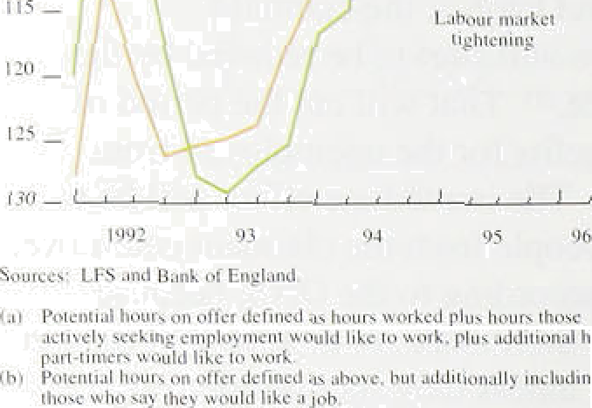

_ , classified as unemployed—the profile is similar.

” The stock of vacancies advertised at Jobcentres rose by an average of l 1.600 a month in the three months to Septeiriber, up from 7,900 in the three months to June; Vdconcies are now at their highest level since May 1988. But the stock ot’ vacancies has been inflated by the introduction of the Labour Market Software system, designed to deal with the Jobseeker’s Allowance. That has depressed the number of people placed in jobs since the beginning of this year. ' According to the ONS. the effect is likely to persist over the next few months, so vacancies are not currently a good indicator of labour market tightness.

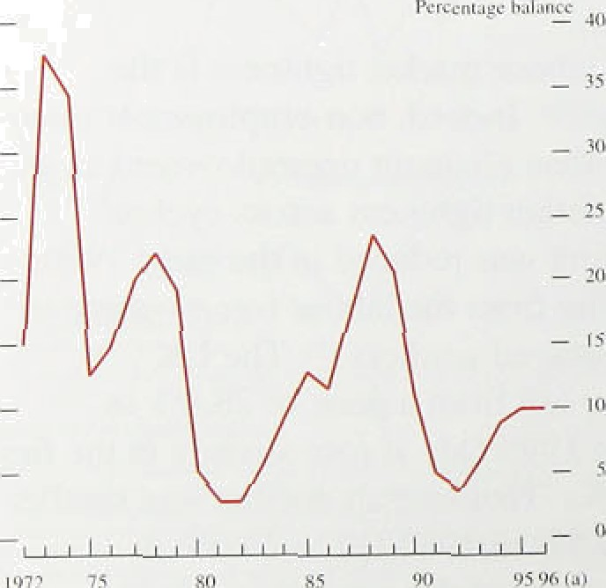Skill shortages have inci’eased sharply in recent years in both the service and manufacturing sectors, according to the BCC Survey. The balance of respondents reporting recruitment difficulties in manufacturing rose fairly steadily from +23% in 1992 Q2 to +64% in 1996 Q3;

in services, the balance rose from a low of +20% in 1991 Q3 to +J7@o in 1996 QS. The ldtest **CBI** Industrial Trends Survey suggests skill shortages in manufacturing are less of a problem than is implied by the **BCC,** however, with a balance of only + l 09o of manufacturers reporting shortages of skilled labour. Chart 4.5 shows

that this measure has crept up from very low levels in the early 1990s, and is now at a similar level to that seen at a similar stage of the previous cycle.

In conclusion. the most comprehensive indicator of labour market tightness—the balatlce between hours demanded and those potentially available to employers suggests that the labour market tightened in the second quarter, after being fairly stable over the preceding year. Other evidence corroborates this picture of a tightening

{J } 7nfIorr.s to vaca»c1es have nn\ hccn affected, but outflows ha're fallen significantly, ar staff at Jnbcen\res have turned their at\ention to the nev/ software.



4 N l n n

Underl!ying nom.i.nal earnings gi owth picked up front 3'/•% in May, at the time. of the previous *lnflnfi ›n Rey‹›rt,* to 4% in August. Both. manu.lecturing and servile sector earnings growth increased. and there were s!gns that private sector nominal earnings accelerated.

Wage ..settlements have also i‘isen over the past few inofiths, after falling in the first few months of the yeiir. Tire.Bank’1s three-month employment-weighted mean settlement—whJch includes data from the CBI, Industrial Relations Services and Income.s Data

Services—was 3.ñ9c in September, up from 3.27 in June bu’t the same as in January. The same pattern was true of public an‹i private sector settlements, which were both 3.59c i.n September, the 4arne as at the beginning of the year.

Nomi.nal earnings depend both on real earnings bargained over by employers and employees .md by the inflation .rate they expect. Each of these are examined in turn .b’elow.

**Chart 4.It**

**Real product u’age per:emplu,›'ee:':**

**..recovcFie:s.compared**

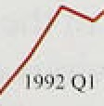

##### Re l e n

'Real product wages per employee ' '—calculated usr nd

.the quarterl.y GDP deflator—have grown more .slowly

.over the .current i’ecovery than over.the previous upturn

.(see Chart 4.6). Indeed, the real product wage, measured in.this .way, increased by 3.1 9c in the first .four year s t›f the current recovery, corripare0 with 5.8' r .in the first 'four years of the upturn in the early 1980s.

" There. are .three main possible explanations. First, real

..wages’rñay not be appropriately measured: the real co.st "'*’ to a .finn. of,employing labour depends on the wage *her*

how.r.rather thsn per week: arid *yrivrite* sector wages may be.a.better.gu:ide to .labour market pressure on vrages; as. wages ifi the public sector are subject to public pay policy: ..Secoiid, real wages rnuy .have been temporarily subdued, and may be about to accelerate.



Third,.there miy ’have been a.step. reduction. during this recovery in th’e.level of real..wages workers were prepared to: accept foi"any given level of unemployment and 1aboh:r productivity: If:so., that would. have e»t3iIed a





shift of the effective supply of labour, increasing the demand for labour by reducing its cost, and resulting in a lower natural rate of unemployment.





One possibility is that *private sector* wages have been increasing at similar rates over the two recoveries. That does not seem to have been the case, however. The split between earnings in the public and the private sector is not available, but it is possible to provide an indication of the different trends by weighting together earnings in education, health and social work and public administration as a rough estimate of public sector

 earnings, and taking the rest to be privately negotiated. Chart 4.7 plots this measure for the private sector; it shows that private sector real wages per worker were much more subdued during the recent recovery than during the early 1980s. The reason is that public sector real wage growth was even more subdued in the recovery of the early l980s, following the sharp rise in public

sector earnings in l980,t l)

An alternative is that the growth of part-time work in  recent years reduced the growth of real wages per

worker, but that real wages *per hour* have been rising at a rate closer to that in previous cycles. That seems to be the case, judging by hourly pay data for full-time employees from the New Earnings Survey. Chart 4.8 shows that real hourly earnings of full-time workers rose by fi.4% in the first four years of the recovery—faster than overall real product wages—only a little less than the 7.5% increase in real hourly earnings in the first four years of the previous recovery. (The fact that part-timers are paid less than full-time workers per hour may simply reflect the fact that their productivity is lower than their full-time counterparts.) Ideally, an appropriate comparison over cycles would use private sector real wages per hour, but those data are not available. And given that unemployment has fallen in the current cycle rather than tising as it did in the previous cycle, real wage growth per hour should have been higher than at that time. So it is not clear that the difference in gfowth rates of real product wages is a question of

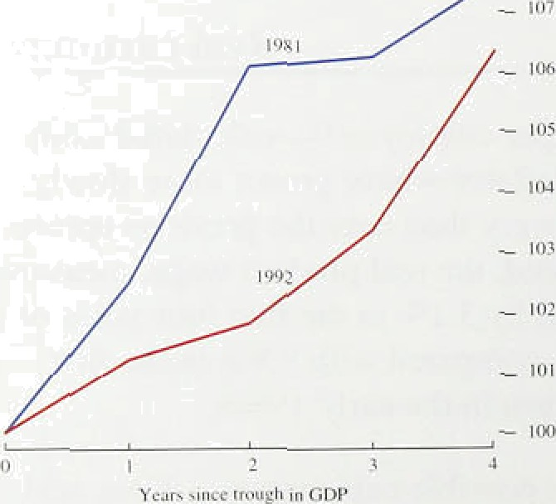

measurement.

*Teinpoiui effects nn wages*

The real product wage per hour is a measure of the cost of the labour to employers compared with the price paid

( I) Ttiix resulted from the Clejg Commission public seclor pay recommendations, which proposed s two-stage rise ctfi up to M.89tt owr



32



for their products that is why it includes employers’ social security contributions and is deflated by the GDP deflator,.a measure of economy-wide prices. But employees are concerned not with the real product

wage per hour, btit the real take-home pay per hour—the real hourly consumption wage. The real consumption wage excludes employers’ social security contributions



.find is deflated by the tax and price index, which takes

.account of changes in direct and indirect taxes as well as prices.

The tax and price index rose by 6&o relative to the GDP deflator in the first four and a half years of the early 1980s recovery, while it did not rise as quickly as the

.GDP deflator in the current recovery. So, whereas the réal product wage per week grew much less rapidly in the early 1990s than in the early l980s, the real consumption wage per week increased much in line with the 3.8% rise over the .first four and a half years in the previous recovery (see Chart 4.9). That meant that greater labour supply was forthcoming ai any real product wage in the 1990s, so allowing employment to grow faster.



What factors allowed .real consumption wages to rise fiuring this recovery, while real product wage growth was mlatively slow? There were three main factors: the terms of tra‹ie, indirect taxes and direct taxes. Fii-st, the

,effect of the terms of trade—the prices people pay for

” imp0rted.goods compared with the prices of goods produce‹i in the United Kingdom—can be examined by considering the ratio of RPIY and the GDP deflator.

That measiire rose by around 1% in the early l980s, but was **broa‹ily** .flat in the early 1990s recovery, so the **térlni** of:trade ha‹i a slightly greater effect on the tax and priEe index during the early 1980s.

Second, the..i!mpact of indirect taxes can be seen in phangm.Pitt the.ratio of the RPIX to RPIY. That rose by US and a half percentage points in the recovery of the **aarly t9803,** but only .two percentage points over the

! 990s’:récovery,. suggesting.that indirect taxes had a lager effect on,the tax an‹i price index in the earlier

Lastly,.the effect:of déect taxes..cam..be seen in changes ill the mtio of tire tax anñ price index to the retail price



percentage point in mole than one percentage point

##### up





direct and indirect taxes all had roughly equal effects creating a larger 'wedge’ between the consumption and product wages in the l98Gs than in the 1990s’ recovery.

I.'liii i i 4.111

li•iliti ol‘ rn :ile non -nuitiuiil u eekt› st ages







*The i1‹imraI i ‹ill o /” iiii‹’iii /›/‹»!//ic ii/*

Structural changes in the 1980s may have lowered the natural rate of unemployment. The pool of labour firms believe to be on offer may be less than the total supply either because of mismatch in the labour market— between skills, occupations or regions r because workers are not prepared to accept the market-clearing wage. The long-run natural rate of unemployment depends, therefore, on factors which change the degree of mismatch in the labour market or by factors such as job security, the structure of bargaining institutions and the benefit system which affect the wage workers— individually or collectively—are prepared to accept for a given job.

Whai factors might have reduced the natural rate of unemployment recently? First, the change in the qualification period for employment rights from one year to two years in the mid- l980s and the reduction in trade union power probably reduced the bargaining power of those in jobs. These labour market changes may have had a delayed effect on wages—possibly because their impact in the 1980s was offset by the relative increase in demand for skilled workers. A shift in demand away from unskilled workers, reflecting the characteristics of recent technical progress, would increase the relative wages of skilled workers; overall unemployment and overall real wages would rise if wages did not fall sufficiently in the unskilled sector to absorb the excess labour supply. Male non-manual wages stabilised relative to manual wages in 1990. however (see

Chart 4.10), suggesting that the relative demand shock may have come to an end at that time, so that the shock to supply began to dominate.

Second. there may have been an increase in the perceived costs of job insecurity in the early 1990s, if the changing composition of job creation from full-time to part-time temporary employment meant that the penalty attached to losing a full-time job had increase, d t1 Seven out of eight net new jobs created during the recovery were temporary, with one in three both part-time and temporary.

In either case, the current rate of unemployment is still probably above the natural rate of unemployment, and







there is: probably scope for claimant unemployment to continue:to fall.somewhat before generating sign.ificant pressure on Earnings.

The intro‹iuetion of the Jobseeker’s Allowance could

.have a further effect on real wages. if it increases the attractiveness of work relative to unemployment. That would tend to lead to a one-off reduction in real

wages for any given level of productivity, and so

’’ presents an ad‹iitional downside risk to real earnings

.growth.

### I4a6n t on e e a o s

Inflation expectations, measured by the Barclays Basix 8urvey, have been fairly stable across the general public, economists and. finance directors over the past six months both at the one and two-year horizons. But trade union leaders ehpect inflation to be around half a percentage point higher than they did in March. looking

.both one and two years ahead (see Section 6 for further

###### discussion).

47 Sum a

The labour market tightened over the past few months,

**after.being** fairly stable during the preceding year. Nominal earnings growth picked tip. Real wages *per hour* probably increased at similar rates in .the current and previous recoveries, although real wages *per employee* increased much more slowly in the recent

.recovery. There appears to have been a fall in the natural rate of unemployment. The introduction of the Jobseeker’s Allowance is expected to remove around 315,000 people from the claimant count over the next six montfis. It is possible that if.it improves the incentives

of the unemployed to look for work, real wage growth may stay .low for..some time.









I’liar t â.l

l iujnn I prices anal the exchange ralc





Output price inflation has remained subdued’ siiice tire August *Rep*‘Art; !as. liave. i.mport prices. .But input prices picked.up, and a.nu!mbler of iineipected price.!fncreases hel.ped to maintain retail. price inflation 3t.just und’er 3% over the past three months::

## ,, 5 1 o i es n the e han e ate

Non-oil.1import1prices .fell.by I .8%, i!n the ’three merit phs

to August, !and were. 2:.0%: below. their.‘!eve1 a year earlier ' .(:see Chart 5. 1.).. Moré .recently, inqteinents i.n the:

exchange rate rr ay .have.put downward prdssiiré. oir import price i.nflation: The.sterling:effective-exchan.ge

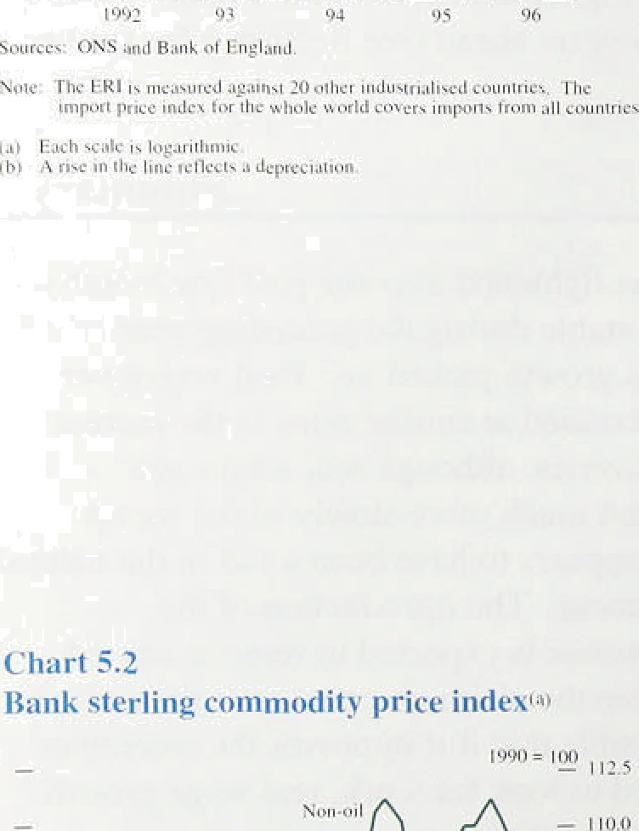' rate index rose from. 84..1 on 2 An ust. to 90.5 on l November. ari appreclation:,o.I.8.l.9 ,.

### Raw inate ia and co od t ce

The .B!ank’s UK demand-weighted corrimodity price:. index rosel2. l âo in Septeriib.er, to 2.7âc above its. level la year earlier: That pick-up was’.caused’by. higher oil. prices: Chart.!5.2 shows"i1ia!t the non-oi!l .index .fell in Septerriber: O.il. accounts!;for. about.a fifth of the Bank’s'. commodity price. ifidex:

A number of cornmodity priegs have fallen.recently:: The prices of.linporté‹i .foodstuffs (such as .cocoa..and

.coffée) .fell ñy. 1.4% in ‘Sepierñber,. reflectin.g stifling’s a.ppreciatioii. !Nietal.s" prices, which account .for fiearly a

,tenth of the Bank's.index,. full .by 4’.4%, i.n Septerriber.m..

.respons.e.t.o.stock build-qps. Agricultural prices; which. aéco'unt:for inore .than’a ithird of.the index, ,fell by 4.2% i.n..August (thé.latest!inonth for w.hié1i data are. available),. That was driven i.n part.by falling wheat prices following a gopd harvest, re:versi!ng price rises earlier in the year,

.And a 3% revaluation of the **‘green!** excharige. rate on

.I November will.reduce:the minimum prices fnrriiérs aye guaranteed for theif pr.oducts. But tlie 'effee“t on retail. 'food prices will be small; in .part because the. range of

.products covere‹di›y tñiiiimiiri prices is..limited:

## 3 Prl iit b odu t o n u t e

The rate of decline’ in .manufaclturers' input costs slowed. in! recent months. Input prices were,unchanged in July





**Input price inftatioii and. thé’ CIPs puich** e

**price indicator**

 



i



and increasled.in the following two months. mainly because of,oil prices: .in September, oil prices rose by 7.0%, adding -0.18% to the producer input price index. The change in..trend was confirmed by other data. Fir.st, tliet input price index which excludes food. drink. tobaclco and petroleum rose by 0.1 In in September, the second monthly increase i.n a row. That followed twel ve. cotislecutive monthly falls. Second, the Chartered Insti.tute of Purchasi.ng and Supply (ClPs) price index rose by 1.1 index points to 44.8 in October, its third

,consecutive monthly increase (see Chart 5.3). Although

the CiPs index did not .reach the neutral 50 level, above wiiich manufactui ers’ i.nput prices are generally rising, the increase in .October suggests .that the official i.nput price index .may have risen faster in October than in eptember.



:'.Tañle’:5:A . past si.x months, as the short-run inflation measures in

iShoi:t-run rfieasiires›iif.prdduceé prici.iriffationo.'. Table 5.A show. But there are some signs of a change in

trend. Output prices rose by 0.4% in September. and



.’weie:2.2% above their .level a year earlier (see



-4.9' -9:1 -2:G .??

Chart 5.4). And a balance of +99r of manufacturers in the October CBI Industrial Trends Survey expected to increase their prices over the next four months, up front



' dunes:(PPI Y.) ' ' ' 2.0









**Ghart 5.**.**4**

**Producer price inflation**







!The ONS has constructed PPIY, a new output price lseries that excludes excise dutiles and is therefore

to. the RP:IY measure of retail price inflation (see Section, I ). The Index has risen more slowly than

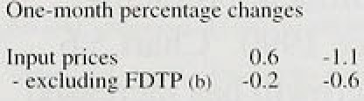

'-”- exrlydiñg FDTP ‹ri. !.0.1.

.”.-.ekcl'uJing excise

0.0 ' 0 :!I



.the:Iieadl.inetfiutput price index since the beginning Of the ye.ar (serf Chai t 5.4). Tfie short-run in.flatioii

°rneasures of PPIY have tended to be even more subdued titan the headline rate over the past six months. because taxes..have increased faster than the prices charged by manufacturers for their output.



About a fialf.of rñanufacturing i.ndustry’s variable costs are dccou:nted”for..by labour, a further quarter by materials afid.fuels (ineludi.rig semi.-finished rianufaétured irriports); and tlie rerriainder by imports ot’ finished:manufactures and bought-i.n servi:ces (such as

:traiisport). Table 3..B shows that domestic .output prices rose niore"tliâii estimate‹J unit. costs fn I9SS Q1. In 1996 Q2 oqtput.prl’ce.increases: slowed and unit costs were unchangéd:’ An‹d in ?hé th.ree. months to .August.

costs an‹i :oiitput ptiees rose at the:’same rate. Downward **pressure** out manufacturers’. costs. from rñaieria'lsi. and ftiels and frotñ import:s pt Fi'nished manufacture s









t lufput ]› r iccx i i 









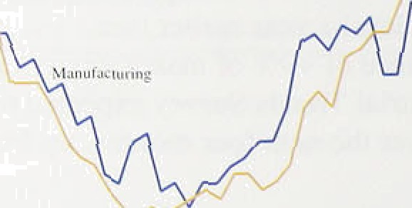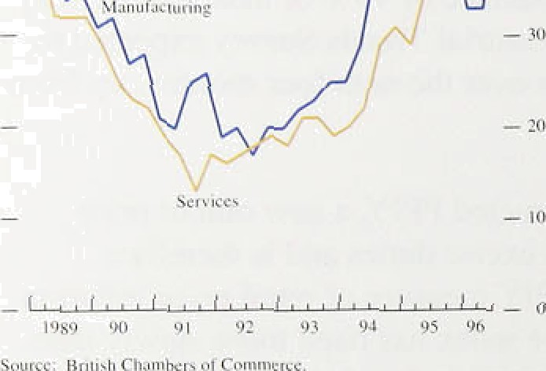

probably outweighed increases in the costs of services over the period. That suggests there may have been an increase in manufacturers’ margins so far this year, in contrast to 1995, when costs rose by more than output prices.

##### 4 P n b e ie s

Service sector price inflation picked up from the second quarter of the year, as discussed in Section 1. Survey evidence suggests that service sector capacity utilisation has increased. The British Chambers of Commerce **(BCC)** Survey asks both manufacturing and service sector firms if they are working at full capacity. As Chart 5.J shows, capacity constraints have risen rapidly over the past 2'/• years in the service sector. In the third quarter of the year, they reached their highest level since the series began in 1989. At the same time, the balance of manufacturing firms operating at full capacity rose to its highest level since 1989. The more firms that are working at full capacity, the more likely it is that firms will respond to an increase in demand by increasing prices in the short run.

The BCC Survey also suggests that there have been recruitment difficulties in the service sector. with the balance of firms experiencing recruitment problems rising in 1996 Q3 to its highest since I S90. Chart 5.6 shows that service sector earnings growth has increased steadily since the beginning of 1996, from 3.09o in the year to January to 3.8% in the year to August (see Section 4).

RPIX goods price inflation currently exceeds output "‘ price inflation. That is unusual. RPIX inflation had

“ been below output price inCation from the third quarter “, of 1992 to April of this year. But the signs are that retail

, margins increased recently.



Cost pressures were subdued during the first half of the year. But input costs have begun to rise, largely because of recent oil price increases. There have also been some signs of a pick-up in producer output *pnce* inflation.



**Pr›%pecJs for inHation i$**

* 1. **Developments in prices,** aggregate

##### d d d I

**:Talile-b.A.**

**.Gro*'th. raies of :comp one9ts: *ot* r.cal.:spcnding**



:, D'nin'esiic. demañd:

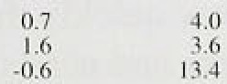





 ”;24



Economic growth has risen during the year. Estimated quarterly .real GDP gi owth was 0.8% in the third luar ter.

.compared with a revisecl estimated average of 0.6'7r to t!he first half of the year and 0.4% dui’ing 1995. But the growth of real domestic demand excluding stoc kbuildinq rose by more. It inci’easeci from an average quarterly rate of,.0.29c .in 1995 to l.07r in the midst 1i‹th’ of 1 996.

Nominal demand has also accelerated over the pasl ye‹ii.

Both consumption and investment accelerated in the first

.hal.f of I.996 (see Table 6.A). Information abotit ltte third.!quarter is. i.ncomplete, but the. signs are that consumption grew i apidly. Household goods sales—an indicator of the demand for durable goods—were particularly strong. Retail sales growth a.s a whole sIowe’d, brit the Q2 figures, boosted by Eui’o ’96. reflected spendin.p• in the United Kingdom by forei_•nc•i‘s rather than .domestic consumption. Consumer confi‹ience improved over the quarter. The Hitlil ax rind Nationwide house price indices both inci eased in the third/quarter, to give ann.ual rates of’ inci’ease of some 59r, .reinforci.n.g the view that consumption is likely to lcontihue to grow Rapidly. The increases in housing turnovei, loan approvals and private housing starts are consistent w.ith. those prospects, too. as is the continuin•_

 sector M4 deposits.



Investment accelerated in the fi.rst hall of 1996, grow in* at an'annualised rate of 6.6%.. Both the British Chamber’s. of Commerce and the **CBI** Surveys .reported that investmeht , intentions remained strong in the third q!uarten: Arid the jtiârket valuation of assets .in the

co oraté sector!increased further above .their replacement. cost, which suggests that it would be profitab e!for. firms to issue eqmi.ty or borrow funds to buy capital gonds. .M4 deposits held by industi ia1 and comri ercial. fiompânies (ICCs),continued to rise strongly, increasinglby .l.1,99a .overlthe year. to the third

!

The signals!:from Cth.e labour mai’ket are consistent with strengtherii:fig output growth: The rfiore.:comprehensive

1 n l l•it i ›u Re a ti i i. oveiul c i I HH(›

indicut‹›i's of labour demand, such as total hours worked i eported in the Labour Force Survey, were f‹iir1y stable tlii’oiighout 1. 99.5 and into spring 1996. But total hours worked picked rip by 0.8"7o between the spring and summer LFS, and employment also gi’ew strongly, suggesting that the labour market started to tighten then. Thut \ras t’ollowed during the thii’d quarter by faster declines in cluirn‹int unemployment and an accelei ation of’ under lying earnings, so the gi owth rate of labour’ demand may have incre.ised further. Private sector earnings. tincoiisti’ained by pay-bill caps, have been

*rowlnj ilslei than those in the public sector. The mite of increase tif car nin s in sei vice sector’ industries started to catch up with the i ate of increase in manufacturing in the middle of hist year, and survey evidence suggests that rcci’tiitircnt difficulties are emerging in the service sector.

The patter n of demand h.as been cftunginp *o›!er* the post year, with a switch from net exr orts to domestic demand. Net exports fell slightly in the fiivst half of 1996.

Nevertheless, gross expoi’t volumes held tip surprisingl y well, given the weakness of demand in most of the United Kingdom’s main tr‹iding par mere. Expoi 1 volumes increased by 3.67r between the second half of 1995 ‹md the first half of 1996, but appear to have been almost flat since then.

Ovei‘all, thcre has been little news over the past quarter‘ to change the pi ospect thiit the faster’ pace of output growth will be iiiaint‹iined. As the output gap closes, the downw‹ird pressure on domestically generated inflation will be i educed. How quickly that happens will depend on tw'o factors, stocks and net e.xpoi is, identified in

ear lier /fe/›r -f.s' as downside risks to output in the near term. First, there is still a downside risk to output from

stocks, as firms probably wish to reduce ,' stock-to-sales ratios further. The main issue is what

aggregate stock-to-.sales ratio is implied by firms’ individual targets, and hence the size of the overhang. Stocks fell i’elative to output in 1996 Q2 and output accelerated in Q3, so it now looks more likely that the stock-to-sales ratio will be brought down gradually, irtainl y by increases in sales rather than reductions in stocks. The risk of a sharp fall in output growth from this source has fallen.

Second. uncertainty about future net exports remains. Prospects for demand growth in continental Europe remain unclear, not least because it is difficult to assess the impact that fiscal consolidation programmes will have. In the first half of 1996, net exports held up better than expected, probably because UK exporters gained

market share and impons may have been reduced by lower stoekbuilding. But those factors are

unlikely to persist, particularly given sterling’s 8% appreciation between 2 August and I November. UK competitiveness is likely to worsen in the short run. The appreciation of sterling is likely to accentuate the emerging imbalance between domestic demand and net exports

The strength of underlying domestic demand suggests that higher output growth will be sustained. Hence inflationary pressure is expected to mount as unemployment approaches its natural rate and firms unit costs are driven up. Output price infiation has been very subdued so far this year, but survey evidence suggests that it is close to a turning point. The October **CBI** Industrial Trends Survey found that more manufacturers expected to increase their prices over the next four months than did in July. Output prices rose in

September. Similarly, the three-month rate of change or’ input prices became positive in September.

The uncertainty surrounding the outlook for inflation is greater this quarter because of the difficulty in interpreting two unexpected developments: first, the failure of **RPIX** inflation to fall over the past quarter and, second, the shatp appreciation of sterling.

Some of the specific price increases that contributed to higher-than-expected RPIX—for example, those for petrol—may have arisen because of adverse ‘supply shocks’, which, provided they do not influence wage and price expectations, ure unlikely to affect the

two-year-ahead inflation rate. But it is difficult to identify many such shocks. Some of the unexpected price increases could be the result of retailers ‘testing the market’ to see what it will bear. Some of those price increases may be unwound. But many of’the price increases, such as those for services such as catering, transport, and insurance and for cars, are more likely to be the result of stronger nominal demand growth, and may therefore signal that inflation is picking up sooner

How.does the appreciation of the exchange rate affect the inflation outlook? Section 2 concluded that the most

pema.ived temporary loosening of monetary policies

eived temporary tightening of United Kingdom and (iii) a rise

exchange rate, perhaps because of the higher



First, to the extent that a perceived temporary loosening of monetary policies overseas was responsible, the reduction in import prices will be unwound gradually as overseas prices rise more than they otherwise would have done. In that case, the nominal appreciation of sterling will have only a temporary effect on the real exchange rate. There will be no lasting impact on the overall price level—a good example of a case where mixing together exchange rate and interest rate changes to assess the stance of monetary policy makes no sense. Inflation will be lower in the short run. Then. as prices start to rise faster abroad, U K import prices will start to increase, too, and the UK retail price inflation rate will go up. Second, if a perceived temporary tightening of UK monetary policy—signalled by the rise in interest rates implied by short-stei’ling futures to levels significantly above 6%—is responsible for the appreciation, its persistence will depend on whether interest rates do indeed rise further.

Third, it’ the equilibrium real exchange rate has risen, the price of tradables will decline relative to non-tradables and. if monetary policy does not offset the first-round effect, there will be a one-off reduction in the aggregate price level. The twelve-month rate of inflation will decline temporarily.

All three explanations entail at least a temporary fall in import prices (relative to the path they would have followed) and a temporary decline in the twelve-month *ro* te of inflation. although only the second—a perceived tightening of monetary policy in the United Kingdom. as reflected in the upward shift of the yield curve at the short end—would imply lower inflation in the long nin.

The Bank’s central projection is based on a judgment that a rise in the real exchange rate accounts for about one half of the appreciation of sterling, the rest being due to the two monetary explanations in roughly equal measure. Because the projection is based on unchanged official interest rates, that part of the appreciation due to recent perceived UK tightening is assumed to unwind.

* 1. **The Bank’s medium•term inflation**

##### o e o

The Bank’s medium-term projection of the twelve-month inflation rate is shown in Chart 6.1, next to August’s projection, shown in Chan 6.2. Official interest rates are assumed to remain unchanged at 6% over the neht two years, and the sterling effective exchange rate is projected to evolve according to differences between nominal interest rates in other countries on the one hand and the constant UK interest rate assumed on the other. Real public spending and effective tax rates are assumed

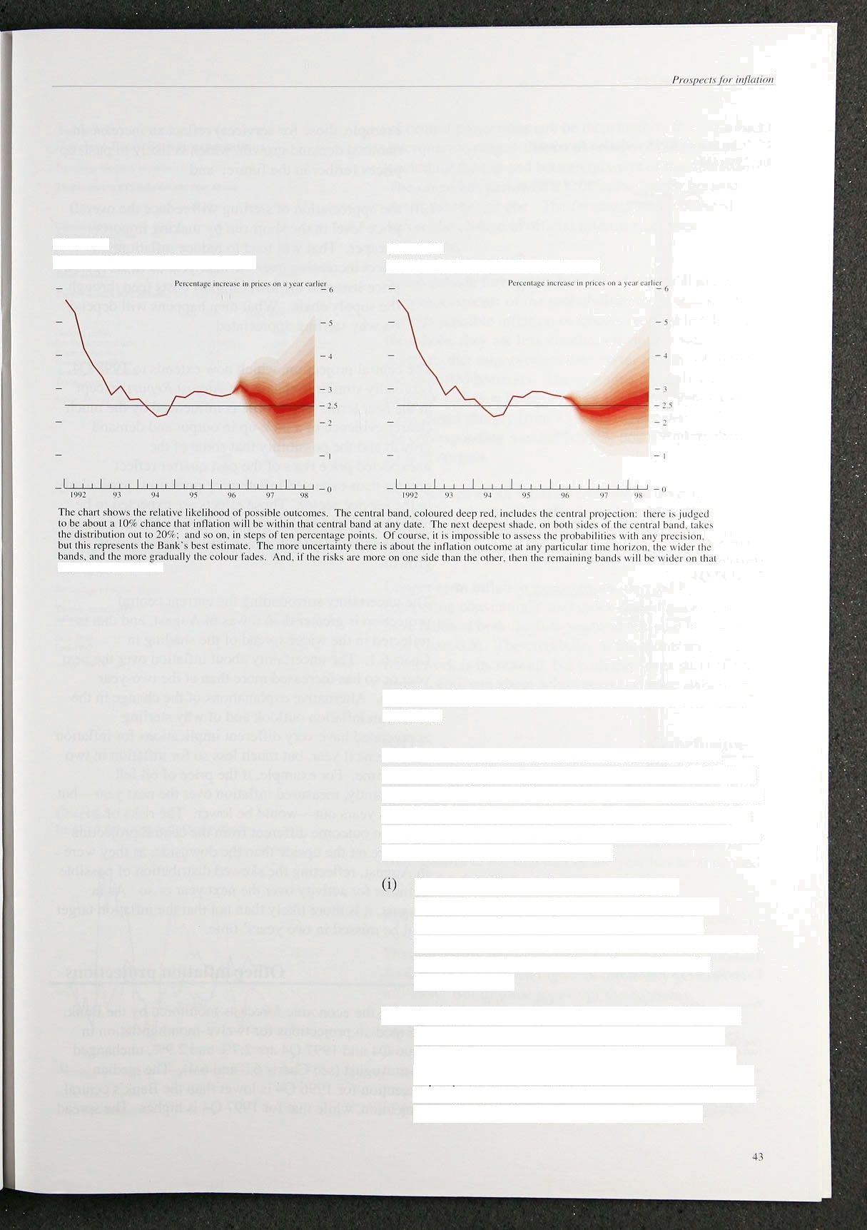Chart 6.1

**Current RPIX inflation projection**

side of tire central bnnd.

**Chart 6.2**

**RPIX inflation pro,iecti‹›n in .4ugusl**

to follow the profile set out in HM Treasui’y’s Summer Forecast.

The Bank’s assessment is that twelve-month RPIX inflation is likely to fall next year after a rise in the final quarter of 1996, reaching a rate around 2'/:% towards the end of 1997. Then it is likely to turn up again, and rise to the end of the forecasting period. This profile reflects the following three considerations:

there probably remains some margin of underutilised resources in the economy. As a result, there is some downward pressure on inflation. But that is expected to diminish and then reverse as output growth continues above its

long-nin trend;

(ii) the higher-than-expected outturns for inflation in the third quarter did not simply reflect one-off adverse supply developments. It is not yet clear why inflation was higher. Some of the unexpected price increases are likely to be unwound, at least in part. But it is likely that some of them (for



example, those for services) reflect an increase in nominal demand growth, which is likely to push up prices further in the fufure; and



 the appreciation of sterling will reduce the overall price level in the short run by making imports cheaper. That will tend to reduce inflation, the effect increasing over the next year as firms review price lists and the lower import costs feed through the supply chain. What then happens will depend on why sterling appreciated.



IJixtriht li‹›n ‹›f' RPIX inflnti‹›n t’‹›i ecnsts I”‹›i i ‘J*J7 /4





The central projection, which now extends to 1998 Q4, is broadly similar to that in the August *Reyort,* except in the near term. The profile is influenced by the much clearer evidence of a pick-up in output and demand growth and the possibility that some of the

unexpected price rises of the past quarter reflect

greater-than-expected inflationary pressures, particularly in the service sector. Those effects are expected to be offset by the '/• percentage point *The* in officia) rates and weaker export demand, which will dampen output growth.

The uncertainty surrounding the current central projection is greater than it was in August, and that is reflected in the wider spread of the shading in

Chart 6.1. The uncertainty about inflation over the next year or so has increased more than at the two-year

, horizon. Alternative explanations of the change in the short-run inflation outlook and of why sterling



**’l’alile I›.II**

Expected **RPIX inflation"**

] 99d Qj 1 21 75

1 9uy Q4 2 2S 57

*-* appreciated have very different implications for inflation over the next year, but much less so for inflation in two years’ time. For example, if the price of oil fell significantly, measured inflation over the next year—but not two years out—would be lower. The risks of an inflation outcome different from the central projection are more on the upside than the downside, as they were in August, reflecting the skewed distribution of possible outturns for activity over the next year or so. As in August, it is more likely than not that the inflation target will be missed in two years' time.

3 Othe n on e ons

Among the economic forecasts monitored by the Bank, the median projections for twelve-month inflation in 1996 Q4 and 1997 Q4 are 2.7&o and 2.99r, unchanged from August (see Charts 6.3 and 6.4). The median projection for 1995 Q4 is lower than the Bank’s central projection, while that for 1997 Q4 is higher. The spread



'I.Um

M‹›ru

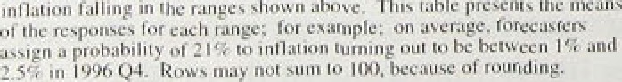









Gcncrul',public





. Trade. uinons:





’



. ñ‹d-9iO

End-99.7.

, iIb

?4







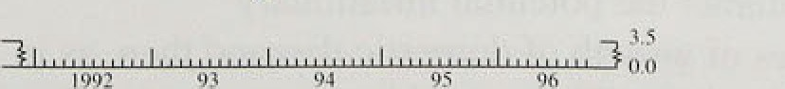



.of central projections can be. measured .by the intqrquartile range: that is, the range of projections excl!uding the top and bottom. quarter.‹ of’ the distribution. The! range has narrowed a I.it tle.at the. longer horizon. but not!at:.tfie shorter. one. The forecasts were collected before the change1in official i.nterest rates was announced.

S.ome outside .forecasters have provided the Bank with

.their a.ssessinents of the probabilities to be attached to various possible inflation outcomes {see TobJc I›. By. On the.whole, they are less uncertai.n than they wei e in

that mi.ghi reflect the shorter lengths of time 10 the •r eci:fled horizons, The average probability attached to RPIX inflation being 2'/.% or below in 1996 Q4 is



.229c, ldown .sharply from 45U‹ in August; for 1997 Q4, thé corresponding number is 27°/e, down st ip•htl y front 339a in Aug:ust.

.Expectations abou.t .i.mation over the next year or so reported by the Barclays Basix rind the Merrill

Lyn‹ih-Gallup Survey.s have changed vet y little on the ivhole. acs tables S.C and 6.D show.

:Lo;n:ger-term inflation expectations. derived by comparing conventional. and index-l inked p•ilt prices. have fallen at both the five-year and ten-year horizons

:(see Chart 6.5). The credibility of the monetary pol icy

!firamework is .i.nereasing, but .both measures still reflect soinii scepticism about achievernenl of pi ice st‹ibil ity in the .1on# run.



,Since. the August */iiJririo/t Reporf,* there have been thi’ee important pieces of news. First. the short-run outlook for inflation has deteriorated. Second, the effective exchange .rate has ri.sen by 8%. Third. the. estimate txt’ GDP growth iri the fii.st half of the ye.ii’ has been revised up, and for the .third quarter is above trend.

Retail pi‘ice .inflat:ion..has been somewhat hip•her than exp‹icted: in!: recent inonths despite weak. cost pressures. T.hat: can partly be attributed to h.i.ther Oil prices rind does:npt in:iise1:I mean higher doii›eslicoll *y* .*eiiei‘ated inflation. But !in soAnne sectors of the.econt›niy, especially services,..there. is evidence thai inereasing• éñpacity utilisation its.p'uiting pressure on retail prices. D,espite tfie sharp rise.:in .the ekfihan.ge!rate, .it. is likely

,that in.fiation .wil!l!:rise fuither béfore weak cost. pressures, as .reflected in. cont-inuing low rates of increase of producer output pfices„1e;id to”a further défiliiie.

Innatinn Report: November 1996

There is now clear evidence that the pick-up in domestic demand has fed through to outpqt growtit. A reduction’ in stockbuilding kept manufacturing .output broadly flat over the past year, but .total output grew at atiove treixl during the thi.r‹1quarter, having grown at about.tren‹i!for. the first half of the year. Real broad!,mo'ney. growth—at an annual rate. of,more tha'n 5 for well.over a year— continues .to signal above-trend growth›in d’emand and output. The main upside risk remains .higher cofisurñer spending,.and .the main downsi‹ie risk is.of weaker exports. Survey data are consistent witli tfiat central view of continuing growth in the domestic economy.

Both the observed rise In inflatlon and the appreciation of sterling Increase lsignificantly lthe sliort-run, uncertainty about **RPIX** inflation. There is1likely.to be a rise in the fourth quaner of this year followed i›y a.slow decline in response to low produced an‹i linport prfce inflation. But inflation is likely to pick up.over the next year or so as capacity is,used up an‹i!demand pressures. result increasingly in higher inflation!.rat1ier! tlian real

activity. Already earnings growth has risen by, about one. percentage point during this year.

Although there is a go.od.‹real of u!ncertainty,gbout where

###### inflation wi.11 be in the..short term, the,.prospect.of

above-trend growth.of ‹remand and output,for1sorne time poses a threat to the in!f1ation..target some two!yeais ahead. Even. after. the recent increase in.officia1,interest rates of '/4 percentage point, il .remains more likely than not that inflation will. be above the .target at the end of the forecast horizon. And the short.-run rise.iñ,lnf1ation .



iñflation target remains elusive.

During the course.of,this yeâr the.bq1aiice of.the recovery shifted from net exports to.grwth.of domestic demand, especially consumption. That trend.is liltely to be reinforce‹i.ñy!the appreciation of ster)ing sineg die August. *In!flatioii Report..* It.wou1ifbe.a misty, however,. to try to lter the balance of the recoyeiy by pursuing an easigr monetary poticyan order to offset the rise.in.the:.exchange.rate. That .vrbu1d.do **nothing to** control the growtli.of,domestic demand. A* appropriate. fiscal pohcy can'help to restrain the gmwtli of eninr public or.private consumption., But If most 4arypnlicy

.fa!11s to'counteract @e potential ndlationafy consequelices of growth oi‘damestic de iaaAtlten,.aa in

>* isie i98°i.'i'er«°*w.•° *°.°"«m°.s‹T&:'*'fi.°i

###### thaw a.strong exehangarate.



A further rise in inflation in the next month t›r two could pose questions about the credibility of the commitment to the inflation target. The i ecent rise in rates should help to reinforce credibil ity. But what matter s most is the continuous pursuit of a monetary policy which is consistent with achieving the target in the medi um term, To ensure this outcome, some fur ther rise in intei’est rates is likely to become neces.sary in due course.

**Glossary and,.other information:,**

Glossary **of’:selected.terms**

**RPI** inflation:' inflalioiri measured lby the retail prices index. **RPIX inflation:** inflation measured!by the .RPI 'Excluding rnortg.age interest payments.

**RPIY** inflation: inflation measured by the RPI excluding mortgage interest payments. and.the.follo,wi.rig.!indirect ,taxes:„

.council tax. VAT. ;1uties, car purchase lax anda Vehicle.excise: duty,.

I nSU tflnCC t‹lX. dfld' dl fQ0ft lilX.

HASP index a Price index w.hich.:, re pfa. ce',s th.e: .mort•a,:ge i'nterest p‹iyments component of the RPI with:a Bank-estimate:iof:the user-cost of’ housing.

THARP index: the.HARP index..excluding,indirect taxes:-.,

MO: notes and coin in circulation.outside:the!.Bahk of.Erig.l4rid and bankers' o.perationa'l. deposits .it.the Bank..

M4: U K nori-bank, non-building society private siécitor’s holdings of notes and coin, togettier wiih ml sterling ‹deposits (including. certi.Creates of dep.osit) helet with U.K ..b.anks..anfi!bui!lding societiés by the non-bank, non-building so.ciety. priv.rite.,sector

**Divisia** money: a.measure of.the money stock!in .which.:each component is weighted according to nrn eslimnte of.how. useful are the. transaction services it provides.

**BCC:** British. Chambers of Commerce.

**BSE:** bovine spongiform! encephalopathy.

CiPs: Chartered Institute-of Purchasing.and\Supply.,

**ICCS:** industrial and commercial compiinies.

**LFS:** .Labour Force Survey.

**OFIs:** other financia'l' institutions.

**TESSA:** tax-exempt special savings accpur;t. WIE: Workfi›ree in Employment.,

e e e t

bhween nt'period: nnd that annual rate.

re onihs e hlie , e*pa‹i eedss:,an ' '

**Symbols and conventions**

n.a... =.not’,8yaiIabI’e...

Because of roundiirg,.the surii of the separate items m y someti'mes!,differ.froñi the total shown.

On the horizontal 'a'xes of graphs, larger ricks denote the first. obsérvatioñ .within tiié relevant peiiod, eg data for the first quarter of the year.

**Othe9nformafon**

Email: . mapubli'cntions.B:bn nkoferiglond.co:uk The Surrimnly of”this'la *poi,!i* is niailable at: [http://www.ñankofengland.co.uii](http://www.ñankofengland.co.uii/)

